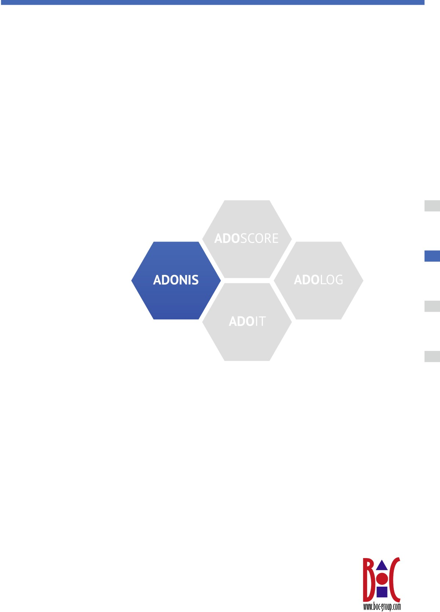**ADONIS NP**

**Version 4.0**

**User Manual**

Books included in this documentation: Administration Manual Installation Manual

User Manual

Web Client Administration Manual

BOC Group Addresses:

Hotline: [hotline@boc-group.com](mailto:hotline@boc-group.com) Homepage: [http://www.boc-group.com](http://www.boc-group.com/)

© User documentation for ADONIS NP 2016

No part of this work covered by the copyright hereon may be reproduced or used in any form or by any means - graphic, electronic, or mechanical, including photocopying, recording, or information storage and retrieval systems - without the prior written approval of BOC Asset Management GmbH.

**The ADONIS NP 4.0 User Manual**

**© 2016, BOC Group**

## Table of Contents

Introduction 1

1. About ADONIS NP and BPMS 2
   1. Concept of the ADONIS Metamodel 3
   2. ADONIS BPMS – The BOC BPM & BPMN 2.0 Best Practice Method 4
      1. Advanced Possibilities with BPMN 2.0 5
      2. Model Types and Supported Application Areas 5
         1. Products 5
         2. Processes 5
         3. Organisation 6
         4. Information Technology 6
         5. Governance, Risk Management, and Compliance (GRC) 7
         6. Other 7
2. Quick Start 8
   1. Create a Business Process in Four Easy Steps 9
      1. (Optional) Show Explorer 9
      2. Create a Business Process 9
      3. Model Happy Path 10
      4. Model Alternative Process Flows 12
   2. Enrich your Model with Additional Information 13
      1. Define Process Borders 13
      2. Provide Additional Information about the Process Steps 14
      3. Visualise Information at Objects as Needed 16
   3. Document Open Issues and Capture Feedback 17
      1. Document Open Questions 17
      2. Generate Open Questions Report 18
   4. Create and Reference Objects 19
      1. Create Repository Objects 19
      2. Reference Repository Objects 20

III Details 21

* 1. "At a glance." – Access Your Personal Dashboard 23
     1. Available Functions 23
     2. The "Design & Document" Scenario 25
        1. Design & Document 25
        2. Search 25
        3. Ownership 26
           1. Owned Processes 26
           2. My Assets 26
           3. Statistics for my Responsibilities 26
        4. News and Tasks 26
        5. Favourites 27
        6. Reports 27
        7. Getting Started 27
     3. The "Control & Release" Scenario 27
        1. Control & Release 28
           1. Overview of Processes 28
           2. All Processes 28
           3. Model Statistics 29
        2. Search 29
        3. News and Tasks 30
        4. Favourites 30
        5. Reports 30
        6. Getting Started 30
     4. The "Read & Explore" Scenario 30
        1. Read & Explore 31
           1. News 31
           2. My Tasks 31
           3. My Processes 31
           4. My Favourites 32
           5. My Company Maps 32
           6. Documents in my Processes 32
        2. Search 32
        3. Portal 32
           1. Processes 32
           2. Documents 32
           3. Organisation 33
        4. My BPM 33
           1. Processes 33
           2. RACI 33
           3. Documents 33

7.4.4.4 IT 34

7.4.4.5 Risks 34

* + - 1. News & Tasks 34
      2. Favourites 34
      3. Reports 34
      4. Dashboards 35
         1. Analyst 35

Process Classification 35

Model Statistics 35

Process Potential Analysis 35

KPI Overview 35

My Processes 35

* + - * 1. Process Owner 36

My Processes 36

Model Statistics 36

KPIs 36

KPI Overview 37

My Assets 37

* + - * 1. Initiatives 37

My Initiatives 37

Initiative Progress 37

My Initiatives - Radar 37

Initiatives 38

* + - * 1. Risks 38

My Risks 38

ICS Statistics 38

My Controls 38

Risk Management Indicators 38

Control Frequency 38

* + - * 1. Compliance 39

My Control Objectives 39

Compliance Statistics 39

Maturity Assessment 39

* + - 1. Getting Started 39
  1. Graphical Modelling 40
     1. Create Models 40
        1. Show/Hide Explorer 40
        2. Create Model 40
        3. Create Objects 41
           1. The Drawing Area 42
           2. The Modelling Bar 42
           3. Switch between General Editing Mode and Drawing Mode 43
        4. Connect Objects 43
        5. Save Model 44
        6. Close Model 44
     2. Edit Models 44
        1. Open Model 44
        2. Reuse Object 45
           1. Differentiation between Repository Objects and Modelling Objects 45
        3. Move Objects 45
        4. Cut/Copy/Paste/Delete Objects 46
           1. Special Case: Insert Object between Two Connected Objects 46
           2. Special Case: Delete Object with Incoming and Outgoing Connectors of One Type .. 46 8.2.5 Connector Functions 46
        5. Model Bendpoints 46
        6. Create New Bendpoint 47
        7. Move Bendpoint 47
        8. Delete Bendpoint 47
        9. Merge Multiple Bendpoints 47
        10. Parallel Translation of Connectors 47
        11. Reallocate Connector 47
        12. Delete Connector 47
     3. Align Objects 48
     4. Number Objects 48
     5. Assign Responsibilities to Tasks 49
     6. Navigate through Open Models, Views etc. 50
     7. Toggle Editor 50
  2. Adjusting the View 50
     1. Use Modes 51
        1. Change Modes 51
     2. Use Property Filters 51
        1. Change Property Filter 52
     3. Change Visible Model Area 52
        1. Scrolling 52
        2. Select Display Detail in the Drawing Area 52
        3. Select Display Detail in the Navigator 52
        4. Zoom 53
     4. Move Drawing Border 54
     5. Use Snap Grid 54
     6. Collapse/Expand Navigation Bar 54
     7. Collapse/Expand Model Header 55
     8. Enter/Leave Fullscreen Mode 55
  3. Add Information to Models and Objects 55
     1. The Notebook 55
     2. Open Notebook 56
        1. Dock/Undock Notebook 57
     3. Edit Attributes 57
        1. Switch between Read Mode and Edit Mode 58
        2. Show/Hide Chapter 58
        3. Show Attribute Information 58
        4. Manage Relations 58
        5. Format Text 59
     4. Check Change History 60
     5. Document Management in the Database 60
        1. Create New Document in the Database 60
        2. Make Documents Available in Different Language Versions 61
        3. Open Document in the Database 61
        4. Delete Document in the Database 61
     6. Upload Images and Display Them in the Graphical Editor 61
        1. Upload new image 62
        2. Make Images Available in Different Language Versions 62
        3. View Image 62
        4. Delete Image 62
     7. Close Notebook 62
  4. Manage Models and Objects 63
     1. The Explorer 63
        1. Show/Hide Explorer 63
        2. Update Content 63
        3. Display/Hide Content 64
        4. Search in Explorer 64
     2. Design Folder Structure 64
     3. Create Object 65
     4. Copy & Paste Objects 65
     5. Move Model/Object 66
     6. Replace Object 66
        1. Relations Behaviour when Using „Replace object...“ 66
     7. Delete Model/Object 67
        1. Prerequisites for Deleting an Object 67
     8. Rename Model/Object 67
     9. The Model/Object Organiser 68
        1. Open Model/Object Organiser 68
        2. Switch between Model Organiser and Object Organiser 68
        3. Open Additional Catalogue 68
        4. Organise Models/Objects 68
  5. Versioning 69
     1. Submit to Methodical Review 70
     2. Submit to Business Review 70
     3. Release Models 70
     4. Reject Models 71
     5. Create New Draft Version 71
     6. Archive Models 71
     7. Check Version History 71

1. Understanding Flows Using the Textual View 73
   1. Open Model in the Textual View 73
   2. Show/Hide Details 74
   3. Sort Cells 74
   4. Select Attributes 74
   5. Open Object Notebook 74
   6. Follow Reference 75
   7. Show in Graphical Editor 75
2. Large-Scale Editing of Attributes Using the Tabular Editor 76
   1. Open Model/Objects in the Tabular Editor 76
   2. Edit Attribute Values 77
   3. Select Cells/Rows 78
   4. Sort Cells 78
   5. Adjust Column Width 78
   6. Select Attributes 79
   7. Add and Remove Objects 79
   8. Open Object Notebook 80
   9. Filter View by Object Type 80
   10. Export Table Content 80
3. Search & Analysis 81
   1. Quick Search 81
   2. Display Hits in Documents 81
   3. Filter Results by Topic 82
   4. From Search to Analysis 83
      1. Refine Criteria 83
      2. Available Filters for Data Analysis 84
   5. Analysis without Search Term 85

|  |  |  |
| --- | --- | --- |
|  | 11.6 Search in Documents only ................................................................................................... | 85 |
| 11.7 Combine Filters ..................................................................................................................... | 86 |
| 11.8 Clear Search Results ............................................................................................................ | 87 |
| 11.9 Save Search Query ............................................................................................................... | 87 |
| 11.10 Manage Stored Search Queries .......................................................................................... | 88 |
| 11.11 Export Search and Analysis Results .................................................................................... | 88 |
| 12 | Usage Analysis ............................................................................................................................. | 89 |
|  | 12.1 Display References ............................................................................................................... | 89 |
|  | 12.2 Display Object Usage in Models ........................................................................................... | 91 |
|  | 12.3 Display Usage Overview of Object ........................................................................................ | 91 |
| 13 | Collaboration ................................................................................................................................. | 92 |
|  | 13.1 Show/Hide "Collaboration" Widget ........................................................................................ | 92 |
|  | 13.2 Subscribe/Unsubscribe to Comments ................................................................................... | 92 |
|  | 13.3 Create Comment ................................................................................................................... | 93 |
|  | 13.3.1 Special Case: Create Model Comment with Open Questions ....................................... | 93 |
|  | 13.4 Post Reply ............................................................................................................................. | 93 |
|  | 13.5 Filter Comments .................................................................................................................... | 94 |
|  | 13.6 Search in Comments ............................................................................................................. | 94 |
|  | 13.7 Show New Comments ........................................................................................................... | 94 |
| 14 | Validation ....................................................................................................................................... | 95 |
|  | 14.1 Run Checks ........................................................................................................................... | 95 |
|  | 14.2 Navigate through Results ...................................................................................................... | 95 |
|  | 14.3 Filter Results ......................................................................................................................... | 96 |
|  | 14.4 Display Full Text of Notification ............................................................................................. | 96 |
|  | 14.5 Display Model/Object ............................................................................................................ | 96 |
|  | 14.6 Mark ToDo as Completed ..................................................................................................... | 97 |
|  | 14.7 Fix Error Automatically .......................................................................................................... | 97 |
|  | 14.8 Fill Mandatory Attributes ....................................................................................................... | 97 |
|  | 14.9 Remove Models/Objects ....................................................................................................... | 97 |
|  | 14.10 Exit Validation ...................................................................................................................... | 97 |
| 15 | Model Comparison ........................................................................................................................ | 99 |
|  | 15.1 Start Comparison .................................................................................................................. | 99 |
|  | 15.2 Results of the Model Comparison ......................................................................................... | 99 |
|  | 15.3 Switch Base Model .............................................................................................................. | 101 |
|  | 15.4 Switch Active Model ............................................................................................................ | 101 |
|  | 15.5 Refresh Results ................................................................................................................... | 101 |
|  | 15.6 Navigate through Results .................................................................................................... | 101 |
|  | 15.7 Export Results ..................................................................................................................... | 102 |
| 16 | Working with Views ..................................................................................................................... | 103 |
|  | 16.1 Available Views ................................................................................................................... | 103 |
|  | 16.1.1 Visualize Relations of the Business Process Architecture with the Matrix View ........... | 103 |
|  | 16.1.2 Compare Objects with the Portfolio View .................................................................... | 104 |
|  | 16.1.3 Visualise Cross-Layer Dependencies with the BIA View (Dependency Analysis) ......... | 105 |
|  | 16.1.4 Compare Objects with the Gantt View ........................................................................ | 106 |
|  | 16.1.5 Visualise Hierarchies and Relations between Objects in a Cluster Map ...................... | 107 |
|  | 16.2 The Matrix View .................................................................................................................. | 107 |
|  | 16.2.1 Expand Matrix View Manually ..................................................................................... | 108 |
|  | 16.2.2 Complete Matrix .......................................................................................................... | 108 |
|  | 16.2.3 Modify Relations between Objects .............................................................................. | 108 |
|  | 16.2.3.1 Modify Relations in a 3-dimensional Matrix ......................................................... | 108 |
|  | 16.2.3.2 Modify Relations in a 2-dimensional Matrix ......................................................... | 109 |
|  | 16.2.4 Change Visualisation ................................................................................................... | 109 |
|  | 16.2.5 Adjust View ................................................................................................................. | 110 |
|  | 16.2.6 Export View ................................................................................................................. | 110 |
|  | 16.3 The Portfolio View ............................................................................................................... | 110 |
|  | 16.3.1 Expand Portfolio View ................................................................................................. | 111 |
|  | 16.3.2 Adjust View ................................................................................................................. | 111 |
|  | 16.3.3 Export View ................................................................................................................. | 111 |
|  | 16.4 The BIA View (Dependency Analysis) ................................................................................. | 111 |

* 1. The Gantt View 111
     1. Expand Gantt View 111
     2. Adjust View 112
     3. Export View 112
  2. The Cluster Map 112
     1. Adjust Evaluation Path 112
     2. Use Model Template 113
     3. Create Model Template 113

1. Reporting Board 114
   1. Open Reporting Board 114
   2. Choose Category 114
   3. Create Reports 114
2. Publishing 116
   1. Create Report 116
      1. Report Options 116
      2. Available Reports 117
      3. Reporting Overview 117
   2. Print Model 118
      1. Print Options 118
      2. Save Model-Specific Print Options 120
   3. Generate Image 120
      1. Graphic Options 121
3. Translation 122
   1. Start Translation 122
   2. Structure of the Translation Editor 122
   3. Translate Content 123
      1. Select Languages for Translation 124
      2. Navigation Shortcuts 124
      3. Get Write Access 124
      4. Filter Translated 125
      5. Automatically Translate Content 125
4. Interfaces 126
   1. Import Objects from Excel 126
   2. Synchronise Objects with other BOC Management Office Products 126
   3. BPMN DI Import 127
   4. BPMN DI Export 127
5. Share or Embed Models 128
   1. Generate URL 128
   2. Embed ADONIS NP as an iFrame 128
   3. Access ADONIS NP via a REST API 129

**IV** **Appendix** **130**

1. Settings 131
   1. Change Password 131
   2. Language 131
   3. Preferences 131
      1. General 131
      2. Modelling 131
   4. Info 132
   5. Help 132
2. Terms and Concepts 133
3. Hints - Did You Know That. 136
4. Sample Solutions 137
   1. Model Happy Path 137
   2. Model Alternative Process Flows 137

**Index** **138**

# Introduction

Welcome to ADONIS NP. ADONIS NP is the multilingual Business Process Management Toolkit from the Management Office of the BOC Group.

ADONIS NP provides among other things a wide range of various functionality in the following operational areas: business process optimisation in accordance with the conceptual approaches of business process re-engineering (BPR) and continuous improvement, quality management, controlling, personnel management, organisation management and information management.

Use ADONIS NP either out-of-the-box (ADONIS NP standard configuration) or expand it to fit your individual needs (ADONIS NP customising - "tailoring").

About this Manual

In the following documentation you find instructions on how to use the manifold functions of ADONIS NP:

* About ADONIS NP and BPMS

This part of the manual contains an overview of the metamodel and the standard modelling methodology of ADONIS NP.

* Quick Start

This part of the manual contains use case descriptions that will help you quickly learn about the most important product functions.

* Details

This part of the manual contains information about the tool components and general functions of ADONIS NP.

* Appendix

This part of the manual contains, among others, a glossary and useful hints and tricks that make working with ADONIS NP easier.

Further Books Included in this Documentation

For *questions about the Administration Toolkit,* please refer to the Administration Manual. For *questions about the installation of ADONIS NP*, please refer to the Installation Manual.

For *questions about the administration of the ADONIS NP web client*, please refer to the Web Client Administration Manual.

# I About ADONIS NP and BPMS

In this part of the manual, the following topics are outlined:

* Concept of the ADONIS Metamodel

A brief overview of the metamodel in ADONIS NP.

* ADONIS BPMS – The BOC BPM & BPMS 2.0 Best Practice Method

An overview of the standard modelling methodology in ADONIS NP and the model types used.

## Concept of the ADONIS Metamodel

ADONIS NP is a method independent tool which does not enforce any specific modelling methodology. The metamodel of ADONIS NP can be configured to optimally suit any particular requirements through customising of the Application Library. The ADONIS NP user can decide how to model business processes and how to best use the ADONIS NP functionalities.

In addition to the possibility to adapt the modelling methodology to the needs of the customer ADONIS NP supports two modelling methodologies by default via the ADONIS BPMS Application Library which is included in the product:

* + BPMS
  + BPMN 2.0

Model Types, Objects and Connectors

Depending on the used Application Library ADONIS NP provides different model types and thus provides support for the integrated presentation of business content in different key areas. For each model type different objects (classes) and connectors (relation classes) are defined. Furthermore, each model type contains different (view) modes which filter the available classes for specific application scenarios.

## ADONIS BPMS – The BOC BPM & BPMN 2.0 Best Practice Method

The ADONIS BPMS (Business Process Management Systems) framework for process management represents a universal modelling methodology for modelling business process architecture. The method is based on the experience and know-how collected by the BOC Group in various business process and knowledge management projects and is an industry-neutral methodology for the modelling, documentation and optimisation of business processes.

The ADONIS BPMS method assumes that a business or organisation is characterised through four key elements:

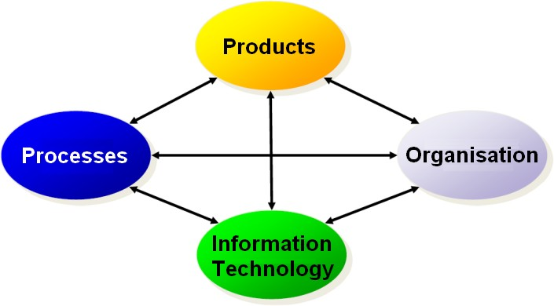

Fig. 1: BPMS Method

* + Products
  + Processes
  + Organisation
  + Information Technology

According to the ADONIS BPMS method there is a reciprocal relationship between these core elements - the products, processes and organisational units are dependent on each other, are implemented through information technology and information technology in turn influences their design.

The available model types enable an integrated and consistent representation on different levels from strategy to deployment-relevant information. Each of the four core elements is supported by one or more model types. For example, the model type "Product Model" allows to model products.

### Advanced Possibilities with BPMN 2.0

Moreover, ADONIS NP integrates the BPMN 2.0 (Business Process Model and Notation) framework which is an international standardised modelling language used for the illustration of processes. BPMN 2.0 aims to offer a tool independent, standardised modelling language, which not only offers a graphical notation but also a formal metamodel.

ADONIS NP provides BPMN 2.0 support with complete process modelling and choreography conformance: in addition to the Business Process Diagram the Choreography and Conversation Diagram are included

### Model Types and Supported Application Areas

This section provides an overview of the model types which are defined in the ADONIS BPMS Application Library and their intended use.

#### Products

Product Model

In a Product Model an overview of products and product components can be created. Product Models can be arranged hierarchically using subordinated models to e.g. illustrate the detailed structure of a product.

Representation of the model type in ADONIS NP: 

#### Processes

Company Map

Company Maps are used to model a process landscape, an overview of business processes or other Company Maps. Therefore a Company Map can be seen as a navigation help and entry point into the hierarchy of your business processes.

Representation of the model type in ADONIS NP: 

Business Process Diagram

The Business Process Diagram allows to model business processes. Representation of the model type in ADONIS NP: 

Conversation Diagram

The Conversation Diagram in ADONIS NP allows an abstracted view of the communication between different participants.

Representation of the model type in ADONIS NP: 

Choreography Diagram

The Choreography Diagram in ADONIS NP allows mapping message exchanges between different participants, typically in the context of B2B scenarios.

Representation of the model type in ADONIS NP: 

#### Organisation

Working Environment Model

Working Environment Models describe the structure of an organisation (organisation chart). Working Environment Models can be arranged hierarchically using subordinated models to

e.g. illustrate the detailed structure of a working environment. Representation of the model type in ADONIS NP: 

#### Information Technology

IT System Model

In an IT System Model an overview of IT system architecture can be created by modelling systems, applications and infrastructure elements. IT System Models can be arranged hierarchically using subordinated models to e.g. illustrate the detailed structure of an IT system.

Representation of the model type in ADONIS NP: 

Use Case Diagram

In Use Case Diagrams interactions between systems and involved parties are shown and described. Involved parties have requirements for the system in order to reach certain goals. These requirements lead to a number of interactions with the system. The system them performs a number of actions to fulfil the requests.

Representation of the model type in ADONIS NP: 

Document Model

Document Models contain documents (templates), which are utilised in processes (input, output to activities etc.). Document Models can be arranged hierarchically using subordinated models to e.g. illustrate the detailed structure of documents.

Representation of the model type in ADONIS NP: 

Data Model

The Data Model provides an easy way to define and describe data entities and their properties. It is particularly useful to define data objects in an enterprise in the context of

defining what information is required and how it can be processed, to model so perceived data structure and define relationships between entities.

Representation of the model type in ADONIS NP: 

#### Governance, Risk Management, and Compliance (GRC)

Control Pool

Control Pools describe the actions that have to be carried out to avoid or prevent the occurrence of risks which have been identified in processes. All controls which occur in processes are thus centrally collected and described.

Representation of the model type in ADONIS NP: 

Risk Pool

In a Risk Pool all risks that occur in processes are collected and described centrally. A risk is a potential danger that can lead to a delay, a malfunction or a complete failure of a process.

Representation of the model type in ADONIS NP: 

Control Objective Pool

The Control Objective Pool offers an opportunity to model, describe, assess and structure control objectives.

Representation of the model type in ADONIS NP: 

#### Other

Analysis Model

The Analysis Model is used to save the results of views and graphical or tabular analyses a as a model.

Representation of the model type in ADONIS NP: 

# II Quick Start

This section of the User Manual will introduce you to some common scenarios when working with ADONIS NP. These should help you to use ADONIS NP efficiently from beginning.

* + - * Create a Business Process in Four Easy Steps

This scenario will guide you through creating a typical business process in ADONIS NP.

* + - * Enrich your Model with Additional Information

This scenario will teach you how to enrich a business process with additional information.

* + - * Document Open Issues and Capture Feedback

This scenario will teach you how to document open issues in a business process and generate a report from this data.

* + - * Create and Reference Objects

This scenario will teach you how to capture and reference objects which represent business content.

## Create a Business Process in Four Easy Steps

This scenario will guide you through creating a typical business process in ADONIS NP. You will learn how to:

* (Optional) Show Explorer
* Create a Business Process
* Model a Happy Path
* Model Alternative Process Flows

**Example Scenario: The ADO Hotel**

The ADO Hotel is a medium-sized boutique hotel known for its excellent service and amenities. As the new business analyst of the ADO Hotel your task is to model the existing business processes in ADONIS NP in order to provide transparent information for decision making to the management team. "Room booking via email" is the first process that has been prioritized for detailed flowcharting.

The following training tasks will familiarize you with the typical activities in this context.

### (Optional) Show Explorer

In order to model a business process in ADONIS NP you have to create a model first. You can access this function in the Explorer.

For details on how to show the Explorer please refer to the section Show/Hide Explorer.

**Example Scenario: What needs to be done here?**

Show the Explorer now if it is hidden.

### Create a Business Process

*Business Process Diagrams* in ADONIS NP let you model the sequence of tasks that are needed to resolve a specific business process. Therefore the first step when creating a business process in ADONIS NP is to create a new *Business Process Diagram*.



For details on how to create a model please refer to the section Create Model.

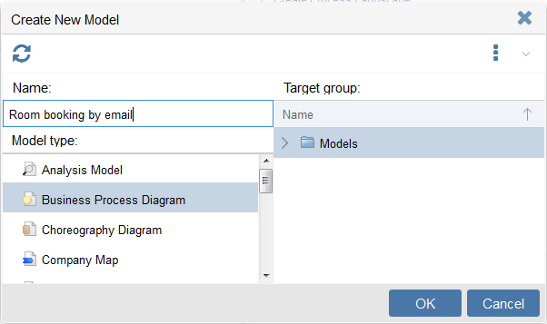

**Example Scenario: What needs to be done here?**

Create a model with the following parameters:

* Model type: *Business Process Diagram*
* Name: "Room booking by email"

Create this model in the standard model group ("Models").

Fig. 2: Create a Business Process

### Model Happy Path

Consider the happy path, i.e. the default scenario featuring no exceptional conditions. Model the process steps in the graphical editor.

For details on how to do model objects and connectors, please refer to the sections Create Objects and Connect Objects.

**Example Scenario: What needs to be done here?**

Model the happy path of the process "Room booking via email". Possible tasks in this context may include e.g. "Book room as per request" and "Send confirmation".

The following objects and connectors will help you complete this task:

Start Event



Every *Business Process Diagram* must contain exactly one *Start Event* object, which symbolizes the beginning of the process:

Fig. 3: Start Event

Usually, the *Start Event* is given the name of the business process. The *Start Event* has exactly one successor, e.g. the first task.

Task

*Tasks* describe which tasks in a business process are to be executed:

Fig. 4: Task

*Tasks* can contain a variety of additional information (e.g. descriptions, responsible roles, documents,...) via the attributes in their Notebooks. They have at least one predecessor and at most one successor.

End Event

Every *Business Process Diagram* can contain one or more *End Event* objects. They mark the end of a path of a business process.

Fig. 5: End Event

The object *End Event* has at least one predecessor and no successor.

Sequence Flow

The *Sequence Flow* connector defines the flow of activities and decisions in a business process. It can be used to link most types of objects.

Fig. 6: Sequence Flow

**Sample Solution**

Click here to take a look at a sample solution for this training task.

### Model Alternative Process Flows

Consider alternative process flows, i.e. scenarios where the aim of the process is not directly achieved. Model the process steps in the graphical editor.

Example Scenario: What needs to be done here?



Model alternative process flows of the process "Room booking via email". Possible tasks in this context may include e.g. "Send refusal and suggest alternative dates" if no room is available:

* Create alternative paths within a process flow by using the *Exclusive Gateway*

object.

* If you want to insert an *Exclusive Gateway* object within the process flow you have already modelled, move other objects by *drag and drop* to create space.
* Press *<Del>* to delete objects/connectors that are no longer needed.

Exclusive Gateway

*Exclusive Gateway* objects characterize decisions within the process flow.

Fig. 7: Exclusive Gateway

The possible decision alternatives can be visualized at the outgoing connectors, e.g. "Yes" or "No". An *Exclusive Gateway* has at least one predecessor and at least two successors.

Sample Solution

Click here to take a look at a sample solution for this training task.

Congratulations

With this step you have accomplished creating your first business process.

## Enrich your Model with Additional Information

This scenario will teach you how to enrich a business process in ADONIS NP with additional information. You will learn how to:

* Define Process Borders
* Provide Additional Information about the Process Steps
* Visualise Information at Objects as Needed

**Example Scenario: The ADO Hotel**

As the new business analyst of the ADO Hotel you have already modelled your first business process in ADONIS NP. Now you want to edit the model attributes and the object attributes to further enrich your model with additional information.

The following training tasks will familiarize you with the typical activities in this context.

### Define Process Borders

Consider the process borders, i.e. the trigger and the result of the process. Enter this information in the Notebook of the model.

For details on how to open the Notebook of a model and enter information in it, please refer to the sections Open Notebook and Edit Attributes.

**Example Scenario: What needs to be done here?**

To define the process borders you have to edit the model attributes in the chapter "General information" which is displayed upon opening the Notebook:

* Describe the purpose of the process in the field *Aim*.
* Describe the trigger of the process in the field *Trigger*.
* Describe the result of the process in the field *Result*.

Finally, it is advisable to enter a brief description which characterizes the process in the field *Description* as well at this stage.

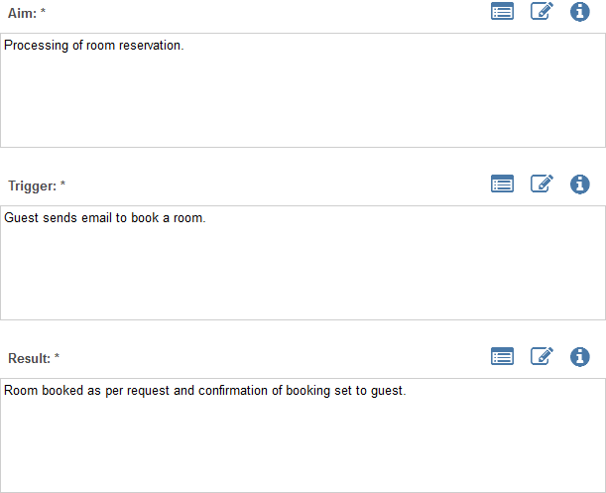

Fig. 8: Define Process Borders

### Provide Additional Information about the Process Steps

Consider what additional information you want to provide for each process step. Enter this information in the Notebooks of the *Tasks* of the *Business Process Diagram*.

Depending on the modelling objective, the following kind of information should be provided:

* A short description of each process step.
* The responsibilities of various roles for each process step according to a RACI matrix.
* A classification, inputs, outputs, IT systems, risks etc. depending on the application scenario.

In general, regard the modelling guidelines of your company and hence the specified mandatory attributes which are marked red in the Notebook.

For details on how to open the Notebook of an object and enter information in it, please refer to the sections Open Notebook and Edit Attributes.

Example Scenario: What needs to be done here?

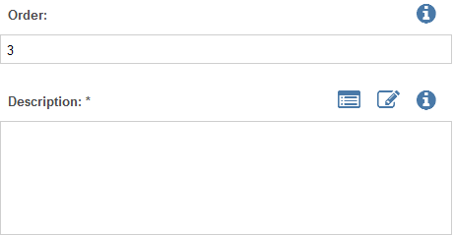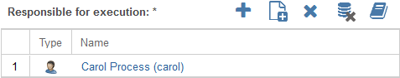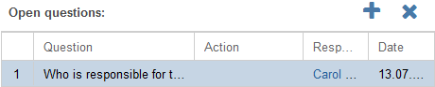

Open the Notebook of a *task* in your business process and edit the mandatory attributes such as *description* and *responsible for execution*.

The most common types of attributes are:

Text Attributes

In single-line or multi-line text fields, text can be entered freely.

Fig. 9: Text Attribute

Reference Attributes

Reference attributes are used to manage relations between objects.

Fig. 10: Reference Attribute

Table Attribute

Table fields are multi-line reference fields where additional information can be maintained.

Fig. 11: Table Attribute

### Visualise Information at Objects as Needed

Only a few key attributes, such as e.g. the name of an object, are displayed directly as text. Many other attributes can be visualised by small pictograms:

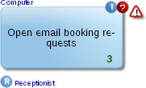

Fig. 12: Visualised Attributes

Consider which attributes you want to visualise and adjust the settings in the Notebook of the respective object accordingly.

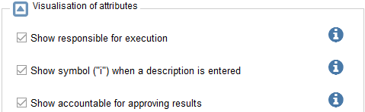

**Example Scenario: What needs to be done here?**

Select an *Task* and open its Notebook. To define which attributes are visualised on the drawing area you have to tick the relevant checkboxes in the chapter *Representation*:

* If you have not already done so, enter a brief description which characterizes the *Task* in the attribute *Description*. You can find this attribute in the Notebook chapter *General information*.
* Activate *Show symbol ("i") when a description is entered* and watch the results on the drawing area.

Fig. 13: Visualise Information at Objects as Needed

**Congratulations**

With this step you have accomplished enriching a *Business Process Diagram* with additional information.

## Document Open Issues and Capture Feedback

This scenario will teach you how to document open issues in a business process and how to generate a report from this data to capture feedback. You will learn how to:

* Document Open Questions
* Generate Open Questions Report

**Example Scenario: The ADO Hotel**

As the new business analyst of the ADO Hotel you have already modelled your first business process in ADONIS NP and enriched this model with additional information via the object attributes. However, the responsibilities for each process step have not yet been clarified. Therefore you want to prepare a report which addresses these open questions for the next project meeting.

### Document Open Questions

Consider what open issues remain regarding each process step. Document these issues in the Notebooks of the *Tasks* of the *Business Process Diagram*.

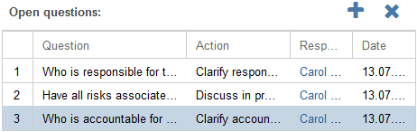

**Example Scenario: What needs to be done here?**

Select a *Task* and open its Notebook:

* Click the icon to add a new row in the attribute *Open questions*. You can find this attribute in the Notebook chapter *CIP*.
* Enter one or more questions, e.g. "Who is responsible for the execution of this process step?".
* Repeat these steps for the other *Tasks* of the *Business Process Diagram*.

Fig. 14: Open Questions

### Generate Open Questions Report

Generate an Open Questions Report to facilitate addressing any open issues with your colleagues.

For details on how to create reports please refer to the section Create Report .

**Example Scenario: What needs to be done here?**

Generate an Open Questions Report:

* Select your model in the Model Catalogue.
* Right-click the model, point to *Reports*, and then click *Open questions report*.

Once your web browser has finished downloading the report, check the resulting PDF document.

**Congratulations**

With this step you have accomplished documenting open issues in order to capture feedback.

## Create and Reference Objects

This scenario will teach you how to capture objects which represent business content in the Object Catalogue and reference these objects in a business process. You will learn how to:

* Create Repository Objects
* Reference Repository Objects

**Example Scenario: The ADO Hotel**

As the new business analyst of the ADO Hotel you have already modelled your first business process in ADONIS NP and clarified the responsibilities for each process step during a project meeting. Now you want to capture the responsible roles in ADONIS NP and reference them in your business process.

### Create Repository Objects

Consider which objects you want to reuse or reference in different models. Create these objects in the Object Catalogue.

Depending on the modelling objective, different objects may be considered for this purpose:

* *Roles* that participate in completing tasks for a business process.
* *Documents* which are required for the realization of a task.
* *Risks* that prevent the achievement of set objectives.
* *Controls*, *Applications*, *Services* etc. depending on the application scenario.



For details on how to create objects in the Object Catalogue please refer to the sections Design Folder Structure and Create Objects.

For details on how to import external files into the database please refer to the section Document Management in the Database.

**Example Scenario: What needs to be done here?**

The receptionist of the ADO Hotel is responsible for managing room reservations. In order to capture this role in ADONIS NP:

* Create an object group "Roles".
* On the basis of a *Working Environment Model*, create a *Role* "Receptionist" in this group.

### Reference Repository Objects

Create relations between your newly created objects and the objects of your business process.

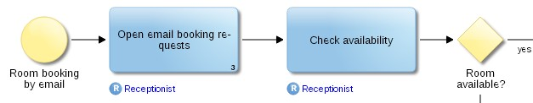

**Example Scenario: What needs to be done here?**

In order to document responsibilities for each process step of your business process:

* Select a *Task* and open its Notebook.
* Select the *Role* "Receptionist" in the Object Catalogue and insert it in the attribute *Responsible for execution* by *drag and drop*. You can find this attribute in the Notebook chapter *RACI*.
* Repeat this step for the other *Tasks* of your business process or transfer the attribute value in the tabular model editor.

The responsible role is visualized on the drawing area:

Fig. 15: Reference Repository Objects

**Congratulations**

With this step you have accomplished creating objects in the Object Catalogue and referencing them in your business process.

# III Details

In this part of the manual you find instructions on how to use the manifold functions of ADONIS NP.

* "At a glance." – Access Your Personal Dashboard

An overview of the start page which provides links to some of the most frequently used functionalities of ADONIS NP.

* Graphical Modelling

This chapter provides an overview of the most important functions for the graphical gathering of your business process architecture information, its underlying principals and its structure, as well as further relevant artefacts.

* Understanding Flows Using the Textual View

The textual view is especially useful to quickly understand the flow of tasks and decisions in a process.

* Large-Scale Editing of Attributes Using the Tabular Editor

The tabular editor offers the opportunity to clearly display object attributes, even in large models. Attribute values can be edited quickly and extensively.

* Search & Analysis

You can quickly search for specific models and objects using the search function of ADONIS NP. The extended search options and filters allow you to seamlessly refine your search for structured analysis of your data and for your reporting.

* Usage Analysis

The usage analysis functions allow you to display references of models and objects, help finding broken references and let you quickly find out in which models an object is used.

* Collaboration

This chapter provides an overview of the most important collaboration functions of ADONIS NP.

* Validation

The validation functions in ADONIS NP allow you to check whether models and objects comply to the modeling guidelines.

* Model Comparison

The graphical comparison of models makes the differences between two models visible.

* Working with Views

This chapter provides an overview of the most important functions for working with views.

* Reporting Board

The Reporting Board allows you to create different reports from one central dashboard.

* Publishing

This chapter provides an overview of the most important publication functions of ADONIS NP.

* Translation

This chapter provides an overview of functions for translating models and objects in the database.

* Interfaces

Using the ADONIS NP interfaces data can be imported from other applications into ADONIS NP and exported from ADONIS NP into other applications.

* Share or Embed Models

This chapter provides an overview of the most important functions for sharing models with non-ADONIS NP users or embedding models into other applications.

## "At a glance." – Access Your Personal Dashboard

The ADONIS NP start page provides quick access to some of the most frequently used functionalities of ADONIS NP. When you log in to ADONIS NP, this page is displayed by default.

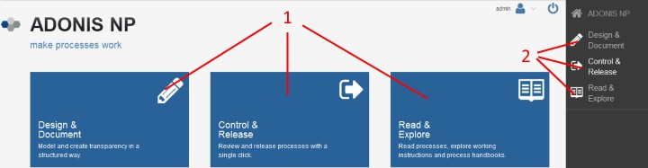

Fig. 16: The ADONIS NP Start Page

The main functionalities are grouped together as part of the application scenarios

* "Design & Document"
* "Control & Release"
* "Read & Explore"

as described in the following sections. You can access these scenarios via the large buttons

(1) or via the navigation bar (2).





The individual functions of the application scenarios are grouped in the form of widgets (= small program windows). When you click the icon or hover the cursor over the title of a widget, ADONIS NP provides a tooltip with information about the widget.

As the ADONIS NP start page is fully customisable, the layout described here may differ from your product configuration.

### Available Functions

Across all widgets and subordinated dashboards of the application scenarios

* + - "Design & Document"
    - "Control & Release"
    - "Read & Explore"

the following functions are available:

Open/Edit Elements

* + - Open a *model* in the graphical editor by clicking its linked name. The only exception to this are *Business Process Diagrams*, which are opened in the textual view in the "Read & Explore" scenario.
    - Open the Notebook of an *object* by clicking its linked name.
    - Open a *task* by clicking it.
    - Show or hide an element in a chart by clicking its name.
    - Switch to the detailed view of a widget via the icon .
    - Confirm the data actuality of an object via the icon .



The time period after which an object is marked as 'yellow' or 'red' if its data actuality was not confirmed by the responsible depends on the configuration of your ADONIS NP installation.

Create Views

* + - Create a matrix view on a model or on one or more objects via the icon .
    - Create a gantt view on a model or on one or more objects via the icon .
    - Create a portfolio view on one or more objects via the icon .
    - Create a BIA view on one or more objects via the icon .

Create Reports

* + - Create an Open Questions Report via the icon .
    - Create an Object Report via the icon .
    - Create a Model Report via the icon .
    - Create a QM Report via the icon .

General Tools

* + - Export the content of a widget as a PDF file or Excel file (XLSX format) via the icon .
    - Refresh a widget via the icon .
    - Open a "Management Dashboard" which contains detailed information regarding your models via the icon .
    - Minimise a widget via the icon .

Interactive Pie Charts

* + - Select the corresponding items in the appropriate list by clicking a segment.
    - Open a separate page which list the corresponding items by double-clicking a segment.

### The "Design & Document" Scenario

The purpose of the "Design & Document" scenario is to let you model and create transparency in a structured way.

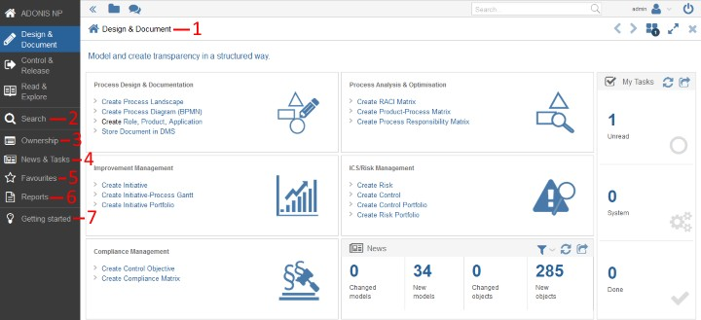

Fig. 17: The "Design & Document" Scenario

From here you have access to:

* + - Design & Document (1)
    - Search (2)
    - Ownership (3)
    - News and Tasks (4)
    - Favourites (5)
    - Reports (6)
    - Getting started (7)

#### Design & Document

This area allows you to quickly start modelling by creating various models and objects. Furthermore, you can generate preconfigured views in one click. You will also get an overview of your tasks and the most recent changes to models and objects in the database. Finally, this area provides the opportunity to store documents in the ADONIS NP database.

#### Search

Quick access to the Search & Analysis is possible via the navigation bar.

#### Ownership

This area is divided into the widgets "Owned Processes", "My Assets" and "Statistics for my Responsibilities".

##### Owned Processes

This widget provides a detailed overview of your processes.

Filter Processes

This selection determines which models will be used to calculate the various diagrams of the "Ownership" area. In order to only display certain processes:

* + - * 1. Click the widget title (button ) to open a drop-down menu.
        2. Select either the menu entry *My* or *Owned*.

*Owned* lists all *Business Process Diagrams* and *Company Maps*:

* For which you are assigned as *Process owner*, *Process manager* or *Process analyst*

(model attributes in the Notebook chapter "Organisation").

*My* additionally lists all *Business Process Diagrams*:

* Which contain *Tasks* for which you are assigned as *Responsible for execution*, *Accountable for approving results*, *Cooperation/Participation* or *To inform* (object attributes in the Notebook chapter "RACI").

##### My Assets

This widget provides a quick overview of your assets. It lists all repository objects for which you are assigned as *Responsible person* (object attribute in the Notebook chapter "Organisation").

##### Statistics for my Responsibilities

This pie chart shows the distribution of version states for your processes.

#### News and Tasks

This area provides a detailed overview of the most recent changes in models and objects in the database and your tasks. This information is also available from the start page, but presented here in a much more detailed form.

Task Options

In order to access the task options:

* Click the widget title (button ) to open a drop-down menu.

The drop-down menu offers the following options:

* Create new task
* Mark selected task(s) as read
* Mark selected task(s) as unread
* Hide or show done tasks
* Mark selected task(s) as done
* Mark selected task(s) as undone
* Delete selected tasks

#### Favourites

This area provides an overview of your favourite models and objects. This information is provided in the form of lists and graphs.

You can check the state and version of your favourite models and keep track of comments.

#### Reports

Quick access to the Reporting Board is possible via the navigation bar.

#### Getting Started

ADONIS NP has a few easy ways to quickly get to work, each one appealing to a different skill level and use case. Read through to see what suits your particular needs.

### The "Control & Release" Scenario

The purpose of the "Control & Release" scenario is to let you review and release processes with a single click.

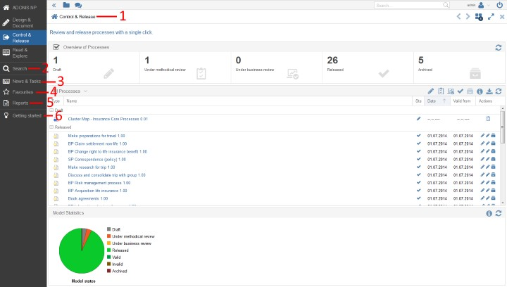

Fig. 18: The "Control & Release" Scenario

From here you have access to:

* Control & Release (1)
* Search (2)
* News and Tasks (3)
* Favourites (4)
* Reports (5)
* Getting started (6)

#### Control & Release

This area is divided into the widgets "Overview of Processes", "All Processes" and "Model Statistics".

The selection of models in the widget "All Processes" determines which models will be used to calculate the various diagrams of the "Control & Release" area.

##### Overview of Processes

This widget shows the distribution of version states for the processes in the database. You can see at a glance how many processes are in which state.

##### All Processes

This widget provides a detailed overview of the processes in the database. The processes are grouped by state and sorted by the date of the last state change (most recent entry in the model attribute *Version history* in the Notebook chapter *Lifecycle*).

Model Release

You can release processes with a single click. In order to execute a transition:

* Click the appropriate icon in the column *Actions*.

Filter Processes by Responsibility

This selection determines which models will be used to calculate the various diagrams of the "Control & Release" area. In order to filter processes by responsibility:

* + - * 1. Click the widget title (button ) to open a drop-down menu.
        2. Select either the menu entry *All*, *My* or *Owned*.

*Owned* lists all *Business Process Diagrams* and *Company Maps*:

* For which you are assigned as *Process owner* (model attribute in the Notebook chapter "Organisation") or:
* Which contain *Processes* for which you are assigned as *Process owner* (object attribute in the Notebook chapter "Organisation").

*My* lists all *Business Process Diagrams* and *Company Maps*:

* For which you are assigned as *Process owner*, *Process manager* or *Process analyst*

(model attributes in the Notebook chapter "Organisation") or:

* Which contain *Tasks* for which you are assigned as *Responsible for execution*, *Accountable for approving results*, *Cooperation/Participation* or *To inform* (object attributes in the Notebook chapter "RACI") or:
* Which contain *Processes* for which you are assigned as *Process owner*, *Process manager* or *Process analyst* (object attributes in the Notebook chapter "Organisation").

*All* lists all *Business Process Diagrams* and *Company Maps* in the database.

Filter Processes by State

This selection only affects the content of this widget. In order to filter processes by state:

* Click the icons , , , or .

You can show or hide models in the state "*Draft*", "*Under methodical review*", "*Under business review*", "*Released*" or "*Archived*".

##### Model Statistics

This widget contains a pie chart showing the distribution of version states for the processes in the database.

#### Search

Quick access to the Search & Analysis is possible via the navigation bar.

#### News and Tasks

This area is identical in both the "Design & Document" and "Control & Release" scenarios. Therefore, please refer to the corresponding description here.

#### Favourites

This area is identical in both the "Design & Document" and "Control & Release" scenarios. Therefore, please refer to the corresponding description here.

#### Reports

Quick access to the Reporting Board is possible via the navigation bar.

#### Getting Started

ADONIS NP has a few easy ways to quickly get to work, each one appealing to a different skill level and use case. Read through to see what suits your particular needs.

### The "Read & Explore" Scenario

The purpose of the "Read & Explore" scenario is to let you read processes, explore working instructions and process handbooks.

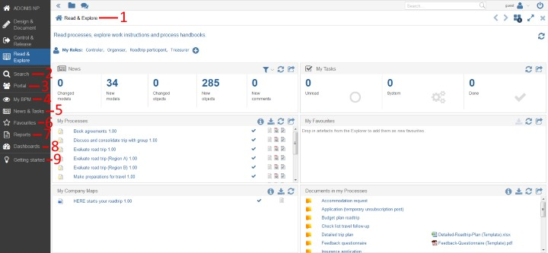

Fig. 19: The "Read & Explore" Scenario

From here you have access to:

* + - Read & Explore (1)
    - Search (2)
    - Portal (3)
    - My BPM (4)
    - News & Tasks (5)
    - Favourites (6)
    - Reports (7)
    - Dashboards (8)
    - Getting started (9)

#### Read & Explore

This area is divided into the widgets "News", "My Tasks", "My Processes", "My Favourites", My Company Maps and "Documents in my Processes".

My Roles

At the top the *Roles* which are associated with your field of responsibility are displayed ("My Roles"). You can add *Roles* from other areas of responsibility. The selection determines which *Roles* are used for calculating various diagrams of the “Read & Explore” scenario.

In order to add *Roles*:

* + - * Click the button .
      * Select the *Roles* you want to add, and then click *OK*.

Manually selected *Roles* are indicated in bold and marked by an asterisk (*).

##### News

This widget provides a quick overview of the most recent changes in models and objects in the database.

##### My Tasks

This widget provides a quick overview of your tasks.

##### My Processes

This widget provides a detailed overview of your processes. It lists all *Business Process Diagrams*:

* + - * + For which you are assigned as *Process owner*, *Process manager* or *Process analyst*

(model attributes in the Notebook chapter "Organisation") or:

* + - * + Which contain *Tasks* for which you are assigned as *Responsible for execution*, *Accountable for approving results*, *Cooperation/Participation* or *To inform* (object attributes in the Notebook chapter "RACI").

##### My Favourites

This widget provides a quick overview of your favourite models and objects. You can check the state and version of your favourite models and keep track of comments.

##### My Company Maps

This widget provides a detailed overview of your *Company Maps*. It lists all *Company Maps* which contain *Processes* referencing your *Business Process Diagrams* (object attribute *Referenced process* in the Notebook chapter "General information").

##### Documents in my Processes

This widget provides a quick overview of documents in your processes. Based on the models in the "My Processes" widget, it lists all *Documents* which are either referenced:

* + - * + In your *Business Process Diagrams* (model attributes *Input* and *Output* in the Notebook chapter "Input/Output" and *Referenced documents* in the Notebook chapter "Documents") or:
        + In the *Tasks* of your *Business Process Diagrams* (object attributes in the Notebook chapter "Input/Output").

#### Search

Quick access to the Search & Analysis is possible via the navigation bar.

#### Portal

Select different usage views from the drop-down menu: "Processes", "Documents" or "Organisation".

##### Processes

This area lists all *Business Process Maps* and *Company Maps* in the state "*Released*" (icon

). Additionally a start model will be displayed.

##### Documents

This area provides an overview of the documents in the database.

Documents by Type

In this widget all *Documents* are sorted by type.

* + - * + Click one of the links to open a list of all *Documents* of a certain type (object attribute

*Document type* in the Notebook chapter "General information").

Documents by Organisational Unit

In this widget all *Documents* are sorted by organisational unit.

* + - * + Click one of the links to open a list of all *Documents* which are referenced in a certain *Organisational Unit* (object attribute *Referenced documents* in the Notebook chapter "General information").

##### Organisation

This area lists all *Organisational Units* in the database. Additionally a start model will be displayed.

#### My BPM

Select different usage views from the drop-down menu: "Processes", "RACI", "Documents", "IT" or "Risks".

##### Processes

This area provides a detailed overview of your processes. It lists all *Business Process Diagrams*:

* + - * + For which you are assigned as *Process owner*, *Process manager* or *Process analyst*

(model attributes in the Notebook chapter "Organisation") or:

* + - * + Which contain *Tasks* for which you are assigned as *Responsible for execution*, *Accountable for approving results*, *Cooperation/Participation* or *To inform* (object attributes in the Notebook chapter "RACI").

##### RACI

This area provides a detailed overview of all process steps in which you are involved through your *Roles*. It lists all *Tasks* for which you are assigned as *Responsible for execution*, *Accountable for approving results*, *Cooperation/Participation* or *To inform* (object attributes in the Notebook chapter "RACI").

The *Tasks* are grouped according to responsible *Roles*.

##### Documents

This area provides a detailed overview of the document usage in your processes. It lists all

*Documents* which are either referenced:

* + - * + In your *Business Process Diagrams* (model attributes *Input* in the Notebook chapter "Input/Output" and *Referenced documents* in the Notebook chapter "Documents") or:
        + In the *Tasks* of your *Business Process Diagrams* (object attributes in the Notebook chapter "Input/Output") or:
        + In the *Processes* of your *Company Maps* (object attributes in the Notebook chapter "Input/Output").

Each occurrence in a model or object attribute is listed in a separate row.

##### IT

This area provides a detailed overview of IT system elements which are referenced in your processes. It lists all repository objects which are either referenced:

* + - * + In your *Business Process Diagrams* (model attribute *Referenced IT system elements*

in the Notebook chapter "Systems/Products" or:

* + - * + In the *Tasks* of your *Business Process Diagrams* (object attribute *Referenced IT system elements* in the Notebook chapter "Systems/Products") or:
        + In the *Processes* of your *Company Maps* (object attribute *Referenced IT system elements* in the Notebook chapter "Systems/Products").

Each occurrence in a model or object attribute is listed in a separate row.

##### Risks

This area provides a detailed overview of risks which are assigned to your processes. It lists all *Risks* which are either referenced:

* + - * + In the *Tasks* of your *Business Process Diagrams* (object attribute *Assigned risks* in the Notebook chapter "Risk management") or:
        + In the *Processes* of your *Company Maps* (object attribute *Assigned risks* in the Notebook chapter "Risk management").

Each occurrence in a model or object attribute is listed in a separate row.

#### News & Tasks

This area is identical in both the "Design & Document" and "Read & Explore" scenarios. Therefore, please refer to the corresponding description here.

#### Favourites

This area is identical in both the "Design & Document" and "Read & Explore" scenarios. Therefore, please refer to the corresponding description here.

#### Reports

Quick access to the Reporting Board is possible via the navigation bar.

#### Dashboards

Select different management dashboards from the drop-down menu: "Analyst", "Process Owner", "Initiatives", "Risks" or "Compliance".

##### Analyst

This area is divided into the widgets "Process Classification", "Model Statistics", "Process Potential Analysis", "KPI Overview" and "My Processes".

The selection of models in the widget "My Processes" determines which models will be used to calculate the various diagrams of the "Process Management" area.

###### Process Classification

This radar chart helps to analyse and classify processes based on the attributes *Predictability*, *Complexity*, *Process frequency*, *Business value* and *Process type* (model attributes in the Notebook chapter "Classification").

###### Model Statistics

This widget contains a pie chart showing the distribution of version states for your processes.

###### Process Potential Analysis

This radar chart helps to analyse improvement potential in your processes based on a simple as-is assessment of the attributes *Quality*, *Cycle time*, *Cost efficiency*, *Customer satisfaction*, *IT support*, *Compliance*, *Risk management* and *Process management maturity* (model attributes in the Notebook chapter "Potential and maturity analysis").

###### KPI Overview

This bar chart allows you to find out quickly if the *Performance Indicators* in your processes meet their target values (based on an assessment of attributes in the Notebook chapter "Details").

More information about the calculation logic can be found in the info texts of the attributes in the chapter "Details".

###### My Processes

This widget provides a detailed overview of your processes.

Filter Processes

The selection in this widget determines which models will be used to calculate the various diagrams of the "Analyst" area. In order to only display certain processes:

Click the widget title (button ) to open a drop-down menu.

Select either the menu entry *My* or *Owned*.

*Owned* lists all *Business Process Diagrams* and *Processes*:

For which you are assigned as *Process owner*, *Process manager* or *Process analyst*

(attributes in the Notebook chapter "Organisation").

*My* additionally lists all *Business Process Diagrams*:

Which contain *Tasks* for which you are assigned as *Responsible for execution*, *Accountable for approving results*, *Cooperation/Participation* or *To inform* (object attributes in the Notebook chapter "RACI").

##### Process Owner

This area is divided into the widgets "My Processes", "Model Statistics", "KPIs", "KPI Overview" and "My Assets".

###### My Processes

This widget provides a detailed overview of your processes. It lists all *Business Process Diagrams* and *Company Maps*:

For which you are assigned as *Process owner*, *Process manager* or *Process analyst*

(model attributes in the Notebook chapter "Organisation") or:

Which contain *Tasks* for which you are assigned as *Responsible for execution*, *Accountable for approving results*, *Cooperation/Participation* or *To inform* (object attributes in the Notebook chapter "RACI") or:

Which contain *Processes* for which you are assigned as *Process owner*, *Process manager* or *Process analyst* (object attributes in the Notebook chapter "Organisation").

###### Model Statistics

This widget contains pie charts showing the distribution of version states for your processes and open questions for the *Tasks* and *Processes* in your processes (object attribute *Open questions* in the Notebook chapter "CIP") .

###### KPIs

This widget provides a detailed overview of your *Performance Indicators*.

Filter KPIs

The selection in this widget determines which *Performance Indicators* will be used to calculate the bar chart in the "KPI Overview" widget. In order to only display certain *Performance Indicators*:

Click the widget title (button ) to open a drop-down menu.

Select either the menu entry *My*, *In my Processes* or *My & In my Processes*.

*My* lists all *Performance Indicators* for which you are assigned as Responsible person (object attribute in the Notebook chapter "Organisation"). *In my Processes* lists all *Performance Indicators* based on the models in the "My Processes" widget. *My & In my Processes* lists both.

###### KPI Overview

This bar chart allows you to find out quickly if your *Performance Indicators* meet their target values (based on an assessment of attributes in the Notebook chapter "Details").

More information about the calculation logic can be found in the info texts of the attributes in the chapter "Details".

###### My Assets

This widget provides a quick overview of your assets. It lists all repository objects for which you are assigned as *Responsible person* (object attribute in the Notebook chapter "Organisation").

##### Initiatives

This area is divided into the widgets "My Initiatives", "Initiative Progress", "My Initiatives - Radar" and "Initiatives".

###### My Initiatives

This widget provides a quick overview of your *Initiatives*. It lists all *Initiatives* for which you are assigned as *Responsible person* (object attribute in the Notebook chapter "Organisation").

You can see at a glance the progress of the *Initiatives* listed here. You can also find out quickly about the data actuality of the listed *Initiatives*.

###### Initiative Progress

This pie chart provides an overview of the progress of your *Initiatives*. The progress is calculated automatically based on a comparison of the "as is" state against the "to be" state of the time, costs and efforts spent on an *Initiative* (object attribute *Progress (Automatic)* in the Notebook chapter "Controlling - Initiative").

###### My Initiatives - Radar

This radar chart helps to analyse and classify your *Initiatives* based on the attributes *Planned costs*, *Current costs*, *Planned effort*, *Current effort* and *Degree of completion* (object attributes in the Notebook chapters "General information" and "Controlling - Initiative").

###### Initiatives

This bar chart categorizes your *Initiatives* based on their *State* (object attribute in the Notebook chapter "Controlling - Initiative").

##### Risks

This area is divided into the widgets "My Risks", "ICS Statistics", "My Controls", "Risk Management Indicators" and "Control Frequency".

###### My Risks

This widget provides a quick overview of your *Risks*. It lists all *Risks* for which you are assigned as *Responsible person* (object attribute in the Notebook chapter "Organisation").

The risks are grouped according to their *Risk Group* (object attribute in the Notebook chapter "General information").

You can see at a glance the severity of the *Risks* listed here. You can also find out quickly about the data actuality of the listed *Risks*.

###### ICS Statistics

The first pie chart in this widget shows the distribution of risk assessment values for your *Risks*. The *Value at risk* is calculated based on the *Likelihood*, *Impact* and *Detection* values of a *Risk* (object attributes in the Notebook chapter "Risk assessment").

The second pie chart shows the distribution of *Control methods* for your *Controls* (object attribute in the Notebook chapter "General information").

###### My Controls

This widget provides a quick overview of your *Controls*. It lists all *Controls* for which you are assigned as *Responsible person* (object attribute in the Notebook chapter "Organisation").

You can find out quickly about the data actuality of the listed controls here.

###### Risk Management Indicators

The first indicator gauge in this widget shows the average value of the *Value at risk* attribute across your *Risks* (object attribute in the Notebook chapter "Risk assessment").

The second and third indicator gauges show the average values of the *Design Effectiveness* and *Operating Effectiveness* attributes across your *Controls* (object attributes in the Notebook chapter "Control assessment").

###### Control Frequency

This bar chart categorizes your *Controls* based on the *Frequency of control execution* (object attribute in the Notebook chapter "General information").

##### Compliance

This area is divided into the widgets "My Control Objectives", "Compliance Statistics" and "Maturity Assessment".

###### My Control Objectives

This widget provides a quick overview of the assets of your *Control Objectives*. It lists the assets of all *Control Objectives* for which you are assigned as *Responsible person* (object attribute in the Notebook chapter "Organisation").

Assets are repository objects which are connected to your *Control Objectives* by the reference *Assigned control objectives*. In the widget, the assets are grouped according to their *Control Objective*.

For each combination of *Control Objective* and asset, you can see whether an action is required and what the maturity assessment of that combination is (attributes in the Notebook of the reference *Assigned control objectives*, chapters "General information" and "Maturity assessment"). You can also find out quickly about the data actuality of the listed assets.

###### Compliance Statistics

This pie charts shows across all combinations of *Control Objectives* and assets to what extent there is need for action (attribute *Action required* in the Notebook of the reference *Assigned control objectives*, chapter "General information").

###### Maturity Assessment

This bar chart provides an overview of the maturity level of your *Control Objectives* by evaluating their assets according to specific categories: undermatch, match, overmatch. The maturity level is calculated automatically based on a comparison of the "as is" state against the "to be" state (attributes *As-is maturity level* and *To-be maturity level* in the Notebook of the reference *Assigned control objectives*, chapter "Maturity Assessment").

#### 7.4.9 Getting Started

ADONIS NP has a few easy ways to quickly get to work, each one appealing to a different skill level and use case. Read through to see what suits your particular needs.

## Graphical Modelling

This chapter provides an overview of the most important functions for the graphical gathering of your business process architecture information, its underlying principals and its structure, as well as further relevant artefacts.

Ideally, before you start modelling a process, it has already been identified on a process map. Responsibilities have been defined and a brief description as well the target, the trigger and result of the process are available. Possibly inputs, outputs and the required applications and potential risks have been identified and documented for the process at the level of the process map.

### Create Models

The following sections provide an overview of the functions needed for creating new models in ADONIS NP.

#### Show/Hide Explorer

The Explorer is located at the left side of the program window. You can use it to both access your models and objects and to create new ones. Depending on the Application Library and product configuration, the Explorer is either visible or hidden at program startup.

Show Explorer

In order to show the Explorer:

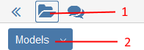

Fig. 20: Show Explorer

* + - * Click the *Explorer* button (1).
      * Select the desired catalogue (models or objects) from the drop-down menu (2).

Hide Explorer

In order to hide the Explorer:

* + - * Click the *Explorer* button again.

#### Create Model

In order to create a new model:

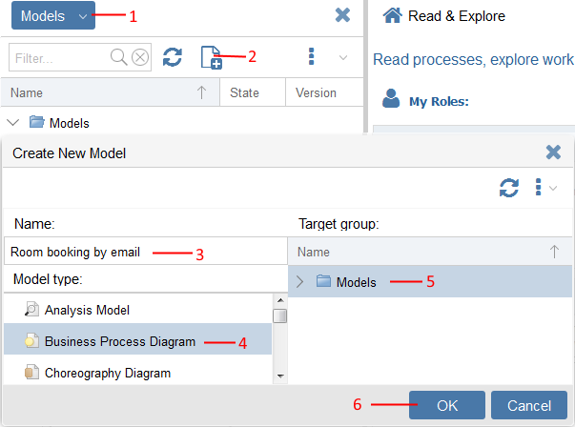

Fig. 21: Create New Model

* + - * Open the Model Catalogue (1). For details please refer to the section Show/Hide Explorer.
      * Click the icon (2). A support dialogue opens.
      * Assign a name to the model (3).
      * Select a model type (4).
      * Define the target folder for the new model (5).
      * Confirm with *OK* (6). The model is created and simultaneously opened in the graphical editor.

Additionally, you can create models directly in the Model Catalogue:

* + - * Select the model group in which the model shall be created in the Model Catalogue.
      * Select *context menu* of the model group - *Create model in group...*.



Unlike names of repository objects, model names need not be unique. Nevertheless, in order to ensure clarity and easy retrieval it is recommended to assign each model name only once.

#### Create Objects

In order to place a new object on the drawing area, proceed as follows:

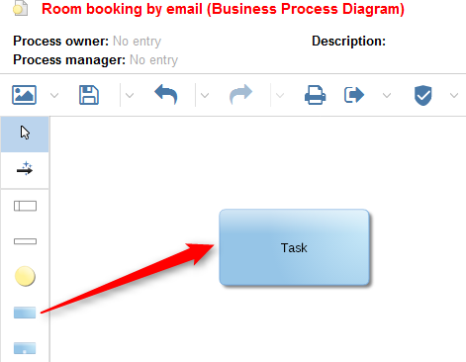

Fig. 22: Create New Object

1. Click the corresponding object icon in the modelling bar.
2. Move the mouse pointer to the desired location of the drawing area where you want to place the object.
3. Click on the drawing area.

The object is drawn and gets assigned a random name. Additionally, you can assign a new name to the object:

* + - * Select the object.
      * Select *context menu* - *Rename* or press *<F2>*.



This scenario particularly applies to modelling objects. Repository objects can also be created directly in the Object Catalogue.

##### The Drawing Area

As soon as a (new or saved) model is opened in the graphical editor, a drawing area appears. All modelled objects and connectors are shown there. Furthermore, a drawing border and the page borders are shown.

##### The Modelling Bar

Whenever a model is shown in the graphical editor, ADONIS NP also activates the modelling bar. It contains icons for all object types that are available in the current mode of the active model. Thus, the look of the modelling bar varies widely.

The modelling bar is divided into two parts: The top end holds the general function icons (e.g. *Edit*, *Create relation*) and below them the available object types are displayed.

##### Switch between General Editing Mode and Drawing Mode

In the graphical model editor the modelling bar provides the user with the objects for modelling. It is possible to switch between a general editing mode and a drawing mode. In drawing mode new objects and connectors can be drawn while the editing mode allows editing existing model content.

Switch to Drawing Mode

In order to switch from editing to drawing mode:

* + - * + Click on any modelling icon.

The chosen modelling type is activated and the corresponding objects can be drawn.

Switch to Editing Mode

In order to switch from drawing to editing mode, you have two options:

* + - * + Click on the arrow at the top of the modelling bar or:
        + Click the right mouse button anywhere on the drawing area.

#### Connect Objects

In order to draw a straight connector between two objects, proceed as follows:

1. Click the *Create relation* icon at the top of the modelling bar.
2. Click on the object the connector should start at.
3. Click on the target object.

For every connector type only certain object types are defined where it may begin or end. When drawing a connector, ADONIS NP instantly checks whether and how the “from and to” objects can be connected. The following cases can occur:

* One Type of Connector Matches "from and to" Objects

The connector is drawn.

* Several Types of Connectors Match "from and to" Objects

A support dialogue opens. All valid connector types for incoming and outgoing connectors are listed as sub items. Choose the desired connector type.

* Target Object Invalid for Connector

The connector cannot be created.

#### Save Model

In order to save changes to a model:

* Click the *Save* button in the menu bar of the model.

Alternatively, you can create a copy of the model:

* Click the down arrow symbol in the *Save* button .
* Select *Save as...* from the drop-down menu.





If a model only allows read access, the *Save* button is replaced by the *Save as...* button in the menu bar of the model.

#### Close Model

Once a model is no longer required for work, you should close it to improve clarity.

Close Active Model

In order to close the currently active model:

* Click the icon at the top right corner of the open model.

### Edit Models

The following sections provide an overview of the functions needed for editing models in ADONIS NP.

#### Open Model

In order to open a model:

* + - * *Double-click* the model in the Model Catalogue.

The model opens in the graphical editor.

In order to open a model with specific settings, proceed as follows:

* + - * Select the model you want to open in the Model Catalogue.
      * Right-click the model, point to *Open as*, and then click either *Graphic*, *Text* or *Table*.

The graphical editor ("Graphic") lets you design, modify and update models. The textual view ("Text") is especially useful to quickly understand the flow of tasks and decisions in a process. The tabular editor ("Table") is ideal for the large-scale editing of attributes.

#### Reuse Object

In order to re-use a single (repository) object from the Object Catalogue in the active model, proceed as follows:

* + - * Use *drag and drop* to move the desired object from the Object Catalogue to the right spot on the drawing area (multiple selection is possible).



If you re-use an object which contains relations to other objects in the active model, the corresponding connectors will be automatically drawn.

##### 8.2.2.1 Differentiation between Repository Objects and Modelling Objects

ADONIS NP distinguishes between repository objects and modelling objects. Repository objects are created and maintained in the Object Catalogue or in models. They can be reused in different models. Modelling objects, by contrast, are maintained only in the models in which they are created. They are not contained in the Object Catalogue.

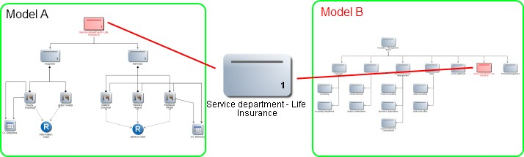

Fig. 23: Repository objects can be reused

Repository objects can be reused. Modelling objects *cannot* be reused.

#### Move Objects

The following options are available:

Move Object

* + - * Move a single object by *drag and drop*.

Move Multiple Objects

* + - * Hold the left mouse button and drag a (red) frame around the objects.
      * Move the objects to their new position by *drag and drop*.

#### Cut/Copy/Paste/Delete Objects

The manipulation functions *Cut*, *Copy*, *Paste* and *Delete* are available in ADONIS NP:

* + - * Press *<Ctrl> + <X>* to cut an object.
      * Press *<Ctrl> + <C>* to copy an object.
      * Press *<Ctrl> + <V>* to paste an object.
      * Press *<Del>* to delete an object.

##### Special Case: Insert Object between Two Connected Objects

Often it is necessary to insert an object between two connected objects. For this purpose, ADONIS NP contains a function that automatically connects the new object to the model structure:

* + - * + Click the connector in question when placing the object. When positioned correctly, the connector is highlighted.

ADONIS NP splits the connector up automatically and connects the new object to the neighbouring objects.

##### Special Case: Delete Object with Incoming and Outgoing Connectors of One Type

When you delete an object that has exactly one incoming and one outgoing connector of one type, a connector is drawn from the preceding object to the following object (auto heal function).

The auto heal function can also be applied to multiple objects at once. When deleting a set of two or more objects with exactly one incoming and one outgoing connector of one type and connectors of the same type running through the set, a connector from the previous to the following object is drawn.

#### Connector Functions

The following sections provide an overview of the functions needed for editing connectors.

##### Model Bendpoints

Connectors can be modelled with any number of bendpoints. In order to do this, proceed as follows:

* + - * + When drawing a connector, click consecutively on all free spaces of the drawing area where you want the connector to bend.

##### Create New Bendpoint

* + - * + Click on the connector at any free spot.
        + Drag it into a new position.

##### Move Bendpoint

* + - * + Click on the bendpoint.
        + Drag it into a new position.

##### Delete Bendpoint

* + - * + Drag the bendpoint to a place where the two adjacent connector lines form a straight line. As soon as the mouse button is released, the bendpoint is deleted.
        + As an alternative, select only the bendpoint and press *<Del>*.

##### Merge Multiple Bendpoints

* + - * + Drag one of two bendpoints over the other.

##### Parallel Translation of Connectors

Horizontally or vertically drawn connectors can be moved as a whole:

* + - * + Select the connector.
        + Move it in parallel by *drag and drop*.

##### Reallocate Connector

* + - * + Select the connection point.
        + Drag it to the new object.

##### Delete Connector

Unnecessary connectors can be easily deleted.

* + - * + Select the connector (click an area of the connector edge without a bendpoint) and press *<Del>*.
        + As an alternative, from the context menu of the connector, select *Delete*.

#### Align Objects

ADONIS NP allows you to automatically align objects in the graphical editor. In order to do so:

* + - 1. Select the objects you want to align.
      2. Right-click the objects, point to *Align*, and then select an alignment option.

Additionally, you can align all objects within a container object (e.g. a *Pool* or *Lane*).

* Right-click the container object, point to *Align*, and then select an alignment option.

Alignment Options

The following alignment options are available:

* Center vertically

Align the objects vertically

* Center horizontally

Align the objects horizontally

* Distribute horizontally

Evenly distribute the objects horizontally

* Distribute vertically

Evenly distribute the objects vertically

* Align right

Align the right side of the objects with the right edge of the right-most object

* Align left

Align the left side of the objects with the left edge of the left-most object

* Align top

Align the top side of the selected objects with the top edge of the top-most object

* Align bottom

Align the bottom side of the selected objects with the bottom edge of the bottom-most object

#### Number Objects

ADONIS NP allows you to automatically assign numbers to the objects in a model. The following options are available:

Number Objects Horizontally

In order to number all objects in the model from left to right:

* + - 1. *Right-click* in the drawing area to open the context menu.
      2. Select *Number objects* - *Horizontal*.

Number Objects Vertically

In order to number all objects in the model from top to bottom:

1. *Right-click* in the drawing area to open the context menu.
2. Select *Number objects* - *Vertical*.

Reset Object Numbering

In order to remove all numbers from the model:

1. *Right-click* in the drawing area to open the context menu.
2. Select *Number objects* - *Reset object numbering*.



Depending on the Application Library, different model types may be considered for numbering. In the ADONIS BPMS Application Library, this functionality is activated for *Company Maps*, *Business Process Diagrams*, *Choreography Diagrams* and *Working Environment Models*.

#### Assign Responsibilities to Tasks

This function can be used to transfer references of container objects (objects that are used to contain other objects) to the objects placed on these container objects. Specifically, you can transfer responsibilities from *Lanes* to the *Tasks* they contain.

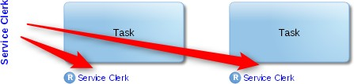

Fig. 24: Assign responsibilities to tasks

The reference must be of the type *Resource* (attribute in the Notebook chapter *General information* of the *Lane*). In the contained *Tasks*, the reference is assigned to the attribute *Responsible for execution* (attribute in the Notebook chapter *RACI*).

In order to assign a resource:

* + - 1. Select a *Lane* on the drawing area.
      2. Right-click the *Lane*, and then click *Assign responsibilities to tasks* .

The reference is simultaneously assigned to all *Tasks* on the *Lane*.



If the reference cannot be transferred because the source attribute and target attribute are not of the same type or if any other error occurs, a message window is displayed.

#### Navigate through Open Models, Views etc.

In order to navigate through models, views etc. you recently viewed:

* Click the < and > arrows at the top right corner of the program window. The previous or next model is brought to the foreground. The models are ordered according to the sequence in which they were opened.
* Click the *Open views* button at the top right corner of the program window. Any models you recently viewed are displayed as tiles. By clicking a tile, you can bring the selected model to the foreground.



The total number of recently viewed models is displayed within the *Open views*

button.

#### Toggle Editor

In order to open the active model in another editor:

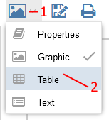

Fig. 25: Toggle editor

* Click the selection button in the menu bar of the model (1), and then click either

*Properties*, *Graphic*, *Text* or *Table* (2).

The Notebook ("Properties") lets you edit the attributes of a model. The graphical editor ("Graphic") lets you design, modify and update models. The textual view ("Text") is especially useful to quickly understand the flow of tasks and decisions in a process. The tabular editor ("Table") is ideal for the large-scale editing of attributes.

### Adjusting the View

The following sections provide an overview of functions that help you adjust the view of your models.

#### Use Modes

In case of extensive, complex modelling methods it often happens that a single model type is used for several use cases. As a consequence, it will contain object and connector types that are only important for some or even one single application scenario. To reduce complexity and at the same time enhance usability for the users, (view) modes can be predefined. In these view modes, unnecessary object and connector types are either greyed out or completely hidden.

Models control the visibility of object and connector types in the following editors:

* + - * Tabular Editor
      * Notebook



Available modes vary depending on the Application Library in use and product configuration.

##### Change Modes

In order to change the active view mode, proceed as follows:

* + - * + Click the button in the menu bar of the open model, and then select a mode.

Additionally, when changing the mode in the tabulator editor, you can fine-tune which attributes are displayed:

* + - * + Select a property filter.
        + Click the button and select the desired attributes. Only attributes that match the active mode are listed.

#### Use Property Filters

When a property filter is active, unnecessary attribute types are hidden. Depending on your role(s) in ADONIS NP, you will get access to different property filters.

**Example**

A property filter for users with a simple reading role could e.g. reduce the amount of visible attributes in the Notebook of an object drastically. A property filter designed for a modeller, on the other hand, would filter no or only a few attributes from the same Notebook.

Property filters control the visibility of attributes in the following editors:

* Tabular Editor
* Notebook



Property filters can be configured in the ADONIS NP Administration Toolkit.

##### Change Property Filter

In order to change the active property filter, proceed as follows:

* + - * + Click the button in the menu bar of the tabular editor or Notebook, and then select a property filter.

Additionally, when changing the property filter in the tabulator editor, you can fine-tune which attributes are displayed:

* + - * + Click the button and select the desired attributes. Only attributes that match the active property filter are listed.

#### Change Visible Model Area

The following sections provide an overview of functions for adjusting the focus and zoom value of the drawing area.

##### Scrolling

In some cases, a model in normal view will be larger than your screen. To adjust the model area, in other words, to scroll in ADONIS NP, follow these steps:

* + - * + *Drag the scroll bars* at the right or bottom border of the model until you reach the desired model region.
        + To *scroll up or down* the display detail, use the mouse wheel.

##### Select Display Detail in the Drawing Area

In order to specify a concrete section of a model for displaying:

* + - * + Hold the right mouse button and drag the mouse pointer over the drawing area.

The necessary zoom factor is calculated automatically.

##### Select Display Detail in the Navigator

The Navigator is a freely floating window showing a general view of the active model. The part of the model which is currently visible is indicated by a coloured border.

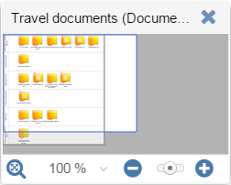

Move Navigator

Fig. 26: Navigator

By default, the Navigator is located at the lower-right corner of the model window. In order to move the navigator:

* + - * + Grab the Navigator window at its title bar and drag it to its new place.

Select Display Detail

In order to adjust the visible model area:

* + - * + Click into the visible area (within the coloured border) and drag it to a new model region or:
        + Place the mouse pointer over the border and drag it to the desired place.

Additionally, the Navigator provides access to various zoom functions.

##### Zoom

With the zoom function, the scale factor of the active model on the screen can be changed from 1% through to 200%. 100% shows the model in original size.

The display size and the visible part of the drawing area in the workspace both depend on the zoom value. For new models, the zoom value is by default 100%.

You can set the zoom value in the Navigator:



Fig. 27: Set Zoom Value

* + - * + Drag the zoom slider to the left or right to increase or decrease the zoom value gradually.
        + Click the icons or to increase or decrease the zoom value to the next 10% (from 43% to 50%, from 70% to 60%…).
        + Click the zoom value in the status bar to unfold a pull-down list from which you can select predefined zoom values, fit the model to the window size or adapt a tailor-made zoom value.
        + Click the icon to fit the model to the window size.



In order to switch rapidly from “factor 100%” to “fit to window size” hold the right mouse button and click on the left mouse button consequently.



In order to change the zoom value using the mouse wheel hold the *<Ctrl>* key while scrolling the mouse wheel up/down.

#### Move Drawing Border

The drawing border is shown as a solid, grey border on the drawing board. It encloses the area where objects and connectors are placed – the drawing area. The drawing area has a variable size.

For moving the drawing border, various options are available:

* + - * Place a new object outside the drawing area. The drawing border will automatically move beyond the placed object.
      * Move an existing object outside of the drawing area. The drawing border will extend automatically.
      * Place the mouse pointer over the drawing border and drag the border line to the desired area.

#### Use Snap Grid

The snap grid is a useful drawing aid for aligning objects and connectors. It is a uniform and unbroken grid covering the whole drawing area of a model. In order to access the snap grid options:

* + - * Click the *More* button in the menu bar of the open model.
      * Point to *Grid* , and then select the desired settings from the submenu.

Depending on your preferences you can:

* + - * *Activate* or *deactivate* the snap grid
      * *Show* or *hide* the snap grid
      * *Change* the snap grid settings

#### Collapse/Expand Navigation Bar

In order to collapse the navigation bar:

* + - * Click the button .

Another click on the button ( ) restores the original size.

#### Collapse/Expand Model Header

If the model type has a model header configured, this header is shown above the open model. The model header contains basic information such as the name and description of the model.

In order to collapse the model header:

* + - * Click the *Information* button ( ).

Another click on the *Information* button ( ) restores the original size.

#### Enter/Leave Fullscreen Mode

You can expand the currently open model, graphical model comparison etc. to fill the entire browser window. In order to do so:

* + - * Click the *Enter fullscreen mode* button .

Another click on the button restores the original size.

### Add Information to Models and Objects

The following sections provide an overview of functions for managing the attributes of models and objects and for managing documents in the database.

#### The Notebook

Models, objects and connectors have certain characteristics, which are called *attributes*. You can view and, if you have sufficient user rights, edit these attributes in the so-called *Notebooks*. In order to increase the clarity and user-friendliness, related attributes are aggregated in *chapters* in a Notebook.

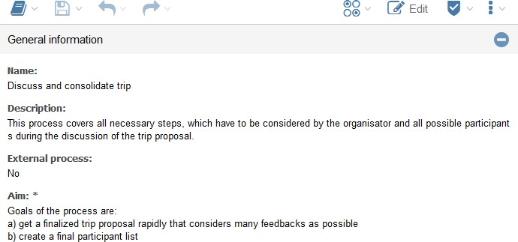

Fig. 28: Notebook of an Object

Global Attribute Values vs. Model-Specific Attribute Values

In ADONIS NP the attributes of repository objects both have global values as well as model- specific values. A repository object that is used in a model after insertion contains the default values from the Object Catalogue. However, some of these values can be adapted specifically for the model without influencing the global values at all.

* + - * Global Values

Properties that are identical in the Object Catalogue and in all models in which the object is used (e.g. name, description).

* + - * Model-Specific Values

Properties that are specific to one object. Model-specific values that have not been specifically adapted in a model automatically use default values (e.g. colour, representation for some classes).

#### Open Notebook

Depending on the attributes to be displayed, the corresponding Notebooks have to be opened from different locations.

Open Model Notebook

Every model has a set of attributes, the so-called model attributes. The composition of these attributes depends on the configuration of the model type in question and therefore can vary widely. You can open the Notebook of a model in the graphical editor:

* + - * *Right-click* on any empty space on the drawing area to open the context menu.
      * From the context menu, select *Properties*.

Alternatively, you can open the Notebook of a model in the Model Catalogue:

* + - * Select the model in the Model Catalogue.
      * Press *<Alt> + <Enter>* or choose *Properties* from the context menu.

Open Object Notebook

All object types, whose attributes shall be accessible, are equipped with a Notebook as well. You can open the Notebook of an object in the graphical editor or in the Object Catalogue. Choose one of the following options:

* + - * *Double-click* the object or:
      * Select the object and press *<Enter>* or:
      * Select context menu of the object - menu entry *Open* respectively *Properties*.

Additionally, you can open the Notebook of an object in the textual view and in the tabular editor.

When opened in the graphical editor, the Notebook of an object opens in a freely floating window.

When you open the Notebook in the graphical editor, the Notebook with the *model-specific attribute values* of the object is opened. When you open the Notebook of a re-usable object in the Object Catalogue however, the Notebook with the *global attribute values* of the object is opened.

These options also allow you to open the Notebook of a connector, if one was defined for it in the product configuration.

##### Dock/Undock Notebook

In order to dock a freely floating Notebook:

* + - * + Click the *Dock* icon in the upper right corner of the open Notebook.

In order to undock a Notebook:

* + - * + Click the *More* button in the menu bar of the open Notebook.
        + Select the menu entry *Undock* .

#### Edit Attributes

Different types of models/objects/connectors have different types of attributes that can be maintained. For simple text attributes the new value can be entered directly into the Notebook or selected there. For complex attributes input support dialogues and other functions are available.

##### Switch between Read Mode and Edit Mode

It is possible to switch between a read mode and an edit mode. Read mode allows for quick browsing of all attributes of a Notebook.

If you want to edit the attributes in a Notebook, you need to switch to edit mode first. In order to do so:

* + - * + Click the *Edit* button in the menu bar of the open Notebook.

In order to switch back to read mode:

* + - * + Click the *Read* button in the menu bar of the open Notebook.

##### Show/Hide Chapter

Open a Notebook chapter to browse the attributes which are aggregated within. In order to show/hide a Notebook chapter:

* + - * + Click the chapter name or:
        + Click the icons or while in edit mode (when the Notebook is docked).

##### Show Attribute Information

Each attribute has an info text that provides you with information about what this attribute is used for. In order to open the info text of an attribute:

* + - * + In edit mode, click the icon .
        + In read mode, hover with the mouse pointer over an attribute.

##### Manage Relations

Manage relations between objects or between objects and models in the Notebooks of the objects/models.

Create New Object

In order to create a new object and reference it in an attribute:

* + - * + Click the icon . A dialogue window opens.
        + Select a name, object type and target folder for the new object. Confirm with *OK*.

Add Reference

In order to reference an existing object or model in an attribute:

* + - * + Select the object or model in the Explorer and insert it in the desired attribute by *drag and drop*.

Alternatively:

* + - * + Click the icon . A dialogue window opens.
        + Select the object(s) you want to reference and confirm with *OK*.



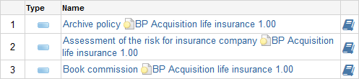

When referencing a modelling object, the model in which the modelling object is maintained is visualised as well.

Fig. 29: Referencing a Modelling Object

Delete Reference

In order to delete a reference:

* + - * + Click the icon .

Delete Reference and Referenced Object

In order to delete a reference and simultaneously delete the referenced object from the database:

* + - * + Click the icon .



If you modify relations between objects, the modified connectors can be displayed in the graphical editor by clicking *update all relations* in the context menu.

Open Model or Object Notebook

* + - * + A referenced model can be opened by clicking on it.
        + A click on a referenced object opens its notebook.

Open Model Notebook

In order to open the Notebook of a referenced model:

* + - * + Click the *Properties* icon .

Open Notebook of a Reference

In order to open the Notebook of a reference:

* + - * + Click the *Open properties of the reference...* icon .

##### Format Text

In order to format a text attribute (e. g. a description):

* + - * + Click the *Edit support window* icon .

A support dialogue opens. You can edit text directly in the text field and format it using the different icons offered by the quick access bar.

You can copy formatted text from other applications into the text window. ADONIS NP recognizes the formatting and applies it to the text.

#### Check Change History

Depending on the product configuration, changes to objects are tracked in a change history. You can access the change history through the Notebook of an object. In order to do so:

* + - * Click the *More* button in the menu bar of the open Notebook.
      * Select the menu entry *Change history* from the drop-down menu.



Only repository objects have a change history.

If you are not able to view the change history, please ask your ADONIS NP administrator to activate the change history in the Administration Toolkit.

#### Document Management in the Database

ADONIS NP allows the import and management of external files in the database. The imported files are maintained as documents in the Object Catalogue. If a repository is exported for backup or migration purposes, the documents in the database are exported as well.

The file types which are allowed for import in the database and the maximum file size (up to 50 MB) can be configured in the Administration Toolkit.

##### Create New Document in the Database

In order to create a new document in the database:

* + - * + Open the Notebook of the *Document* object in which you want to reference the import file. Switch to the Notebook chapter *General information*.
        + Click the *Upload file* icon in the attribute *Referenced document*.
        + Select a file from your file system and confirm. The file is uploaded to the database.

##### Make Documents Available in Different Language Versions

When you add a new document, it is displayed in all languages. To make available the same document in a another language version:

* + - * + Switch to the desired language.
        + In the Notebook of the *Document* object, replace the referenced document via the

*Upload file* icon .

##### Open Document in the Database

In order to open a document in the database:

* + - * + Open the Notebook of the *Document* object including the referenced document. Switch to the Notebook chapter *General information*.
        + In read mode, click the link to the document in the attribute *Referenced document*.
        + In edit mode, click the *Open* icon in the attribute *Referenced document*.

The document in the database opens.

##### Delete Document in the Database

The *Delete* command allows you to delete a *Document* object including the referenced document in the database.

If you just want to delete the document in the database but keep the *Document* object:

* + - * + Open the Notebook of the *Document* object including the referenced document. Switch to the Notebook chapter *General information*.
        + Click the *Remove file* icon in the attribute *Referenced document*. The document is deleted from the database.

#### Upload Images and Display Them in the Graphical Editor

You can upload images into the database in order to use them in models. The images are referenced in the attributes of certain objects (*Notes* and *Cross-References*) and displayed in place of these objects in the graphical editor. If a repository is exported for backup or migration purposes, the images are exported as well.

The file types which are allowed for import in the database and the maximum file size can be configured in the Administration Toolkit.

##### Upload new image

In order to upload an image:

1. Open the Notebook of the *Note* or *Cross-Reference* in which you want to reference the image. Switch to the Notebook chapter *Representation*.
2. Click the *Upload file* icon in the attribute *Link to external graphic*.
3. Select a file from your file system and confirm. The file is uploaded to the database.

##### Make Images Available in Different Language Versions

When you add a new image, it is displayed in all languages. To make available a different image in another language version:

* + - * + Switch to the desired language.
        + Open the Notebook of the *Note* or *Cross-Reference* which contains the image you want to replace. Switch to the Notebook chapter *Representation*.
        + Replace the referenced image via the *Upload file* icon in the attribute *Link to external graphic*.

##### View Image

In order to view an image:

* + - * + Open the Notebook of the *Note* or *Cross-Reference* including the referenced image. Switch to the Notebook chapter *Representation*.
        + In read mode, click the link to the image in the attribute *Link to external graphic*.
        + In edit mode, click the *Open* icon in the attribute *Link to external graphic*.

##### Delete Image

The *Delete* command allows you to delete an object including the referenced image. If you just want to delete the image but keep the object:

* + - * + Open the Notebook of the *Note* or *Cross-Reference* including the referenced image. Switch to the Notebook chapter *Representation*.
        + Click the *Remove file* icon in the attribute *Link to external graphic*. The image is deleted from the database.

#### Close Notebook

In order to close a Notebook:

* Press *<Esc>* or:
* Click the icon .

### Manage Models and Objects

The following sections provide an overview of functions for managing models and objects in the database.

#### The Explorer

Via the Explorer you can access the models and objects saved in the database. The Explorer can be found on the left side of the program window.

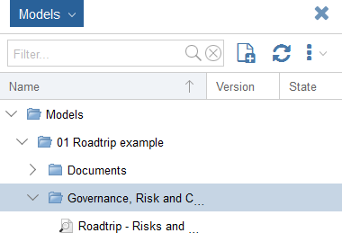

Fig. 30: The Explorer

The Explorer contains the following catalogues:

* + - * The Model Catalogue

Management of models and model groups

* + - * The Object Catalogue

Management of objects and object groups

##### Show/Hide Explorer

Please refer to the section Show/Hide Explorer for details.

##### Update Content

In order to update the Explorer:

* + - * + Click the icon .

##### Display/Hide Content

Content in the Explorer can be shown or hidden by clicking the icons  und  next to the folders. The following additional options are available:

* + - * + Expand Selected Group

A folder needs to be selected. Opens the folder, same function as clicking the icon . Shortcut: *<+>*

* + - * + Collapse Selected Group

A folder needs to be selected. Closes the folder, same function as clicking the icon . Shortcut: *<->*

##### Search in Explorer

The search function is offered as an input field in the menu bar of the Explorer.

Execute Search

In order to execute a search across the currently selected catalogue:

* + - * + Enter the search string into the input field.
        + Press *<Enter>* or click the *Search* icon ( ).

All models or objects that contain the search string in their name are shown.

Clear Search Filter

In order to clear the search filter:

* + - * + Click the *Clear search filter* icon ( ).

#### Design Folder Structure

Design any folder structure in the Model Catalogue or Object Catalogue by creating groups hierarchically.

Create Group

In order to create a model group or object group:

* + - * Select the group in which the new group shall be created in the respective catalogue.
      * Select *context menu* of the group - *Create group*.

The usage of the following functionalities helps design a folder structure: *Copy*, *Paste*, *Delete* and *Rename*. These functions are available in the context menu of groups. Groups can be also moved by using *drag and drop*.

The context menu entry *Translate* is very useful in multilingual scenarios and in designing different folder structures for all languages.

#### Create Object

In order to create an object in the Explorer:

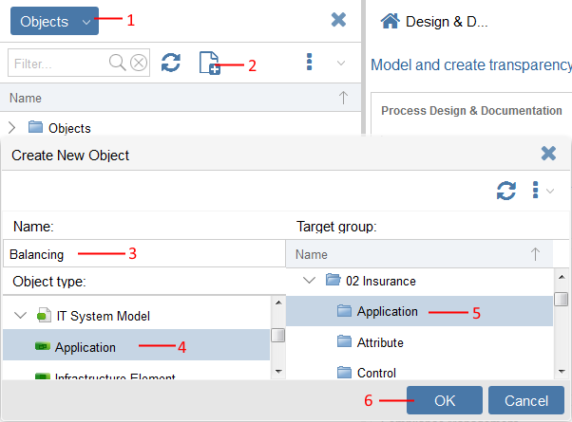

Fig. 31: Create Object

1. Open the Object Catalogue (1). For details please refer to the section Show/Hide Explorer.
2. Click the icon (2). A support dialogue opens.
3. Assign a name to the object (3).
4. Select an object type (4).
5. Define the target folder for the new object (5).
6. Confirm with *OK* (6). The object is created in the Object Catalogue.

Additionally, you can create objects directly in the Object Catalogue:

* + - * Select the object group in which the new object shall be created in the Object Catalogue.
      * Right-click the object group, and then click *Create object in group...*.

#### Copy & Paste Objects

In order to create a copy of an object in the Object Catalogue:

* + - * Press *<Ctrl>* + *<C>* to copy an object.
      * Press *<Ctrl>* + *<V>* to paste an object.

#### Move Model/Object

In order to move a model or object to another group:

* + - * Move the model/object to its new position by *drag and drop* (multiple selection is possible).

#### Replace Object

ADONIS NP offers the possibility to merge two objects of the same type. In order to do so:

1. Select the two objects you want to merge in the Object Catalogue.
2. Right-click the objects, and then click *Replace object*. A dialogue box opens.
3. Select the object that should replace the other one.
4. If you want to transfer attributes from the object to be replaced, perform the following additional steps:
   * Open the Notebooks of both objects by using the provided links.
   * Compare the attributes of both objects and transfer them from one object to the other.
5. Click *Replace*.

##### Relations Behaviour when Using „Replace object...“

The relations of the replaced object are inherited as follows:

* + - * + Incoming relations (icon ): inherited.
        + Outgoing relations (icon ): NOT inherited.

**Example**

The following example shows the behaviour of incoming and outgoing relations of the replaced object. The process "Record customer data" has two incoming relations (superordinated processes "Acquisition life insurance" and "Acquisition retirement insurance") and one outgoing relation (subordinated process "Correspondence (policy)"). The process “Customer Service” has one incoming relation (“Claim settlement”) and one outgoing relation (“Information about performance”). If “Record customer data” is replaced by “Customer Service”, the following happens:

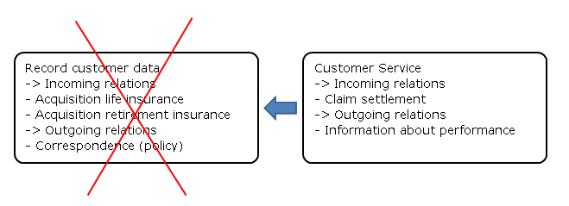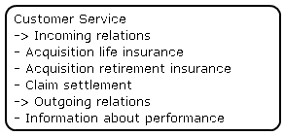

Fig. 32: Object Replacement - Example

Result: “Customer Service” now has three incoming relations ("Acquisition life insurance" ,"Acquisition retirement insurance" and "Claim settlement") and one outgoing relation (“Information about performance”).

Fig. 33: Object Replacement – Example (Result)

#### Delete Model/Object

In order to delete a model or object in the respective catalogue:

* + - * Select the model/object you want to delete.
      * Select *context menu* - *Delete* or press *<Del>*.

The deleted model/object is moved to the recycle bin.

##### 8.5.7.1 Prerequisites for Deleting an Object

In order to delete an object, it must not be used in any model. When trying to delete an object which is still used in models, a dialogue window will pop up.

#### Rename Model/Object

In order to rename a model or object:

* + - * Select the model/object you want to rename.
      * Select *context menu* - *Rename* or press *<F2>*.



When you rename a repository object and the object already exists (same name, same type), you have two options:

* Click *Cancel* and choose a different name or:
* Click *Replace object* and merge the two objects.

#### The Model/Object Organiser

You can open multiple Object Catalogues or Model Catalogues at the same time, side-by- side, to help you organise your objects or models. This feature is called *Model Organiser* respectively *Object Organiser*.

##### Open Model/Object Organiser

In order to open the Model Organiser or Object Organiser:

* + - * + Click the *More* button in the menu bar of the Explorer, and then click either *Model Organiser* or *Object Organiser*.



If the Model Catalogue is open in the Explorer, you can open the Model Organiser. If the Object Catalogue is open in the Explorer, you can open the Object Organiser.

##### Switch between Model Organiser and Object Organiser

In order to switch between Model Organiser and Object Organiser:

* + - * + Click the *Objects* respectively *Models* button .

##### Open Additional Catalogue

In order to open an additional catalogue:

* + - * + Click the large button on the right side of the program window.

##### Organise Models/Objects

The Model/Object Organiser offers the same features as the Explorer. The following commands are especially useful for organising your objects or models:

* + - * + *Copy*, *Paste*, *Delete* and *Rename*.
        + You can drag models, objects or even entire groups from one catalogue to another.



The *Copy* and *Paste* commands are only available for objects. If you want to create a copy of a model, use *Save as*.

### Versioning

ADONIS NP provides a release workflow management system which allows to formalise model release and versioning. During the release process contributors carry out different tasks depending on their roles.

*Modellers* create and submit models to review. They can also create new versions of models which have already been released in order to adapt them.

*Reviewers* manage the model release. They perform methodical reviews and business reviews of the submitted models.

*Administrators* can execute all transitions. They are responsible for the maintenance of the release process. Only *Administrators* can archive models.

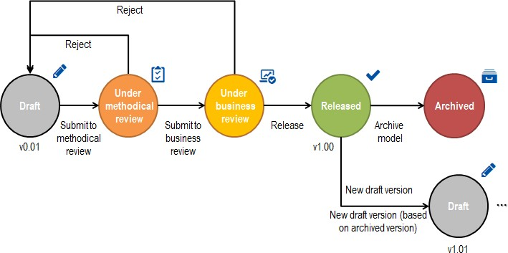

Fig. 34: Release Workflow Standard Configuration

Versioning through release workflow is activated for *Business Process Diagrams* and *Company Maps*. Models of this type which are not versioned have the state "*Draft*" which is displayed by the icon .

Whenever you execute a transition you can assign a change comment. This comment is saved in the model attribute *Version history* in the Notebook chapter *Lifecycle*. Once the transition to a new state is complete, ADONIS NP automatically sends out tasks to notify the responsible user(s).



As the ADONIS NP release workflow component is fully customisable in the Administration Toolkit, the functions described here may differ from your product configuration.

#### Submit to Methodical Review

In order to start a release process, one or more models have to be submitted to the methodical review:

* + - * Select the models you want to submit to review in the Model Catalogue.
      * From the context menu, select *Versioning* - *Submit to methodical review*.

Checks are run to find out if the models are valid, e.g. if they contain any objects and a process responsible has been defined for the models (attribute *Process owner* in the Notebook chapter *Organisation*). The results of the checks are shown in the "Validation" widget at the right side of the program window.

If no errors are found, you can execute the transition. The icon  displays the new state "*Under methodical review*".

#### Submit to Business Review

If no faults were found during the methodical review, you can forward one or more models to the business review:

* + - * Select the models you want to submit to review in the Model Catalogue.
      * From the context menu, select *Versioning* - *Submit to business review*.

Checks are run to find out if the models are valid, e.g. if there are any open ToDos. The results of the checks are shown in the "Validation" widget at the right side of the program window.

If there are no open ToDos, you can execute the transition. The icon displays the new state "*Under business review*".

#### Release Models

In order to release one or more models which have been submitted to review:

* + - * Select the models you want to release in the Model Catalogue.
      * From the context menu, select *Versioning* - *Release*.

The version number of the selected models changes to "*1.00*". The state of the model changes to "*Released*" (icon ).

#### Reject Models

In order to reject one or more models which have been submitted to review:

* + - * Select the models you want to reject in the Model Catalogue.
      * From the context menu, select *Versioning* - *Reject*.

The state of the models returns to "*Draft*".

#### Create New Draft Version

You can create a new draft version based on a released model. In order to create a new draft version:

* + - * Select the model you want to create a new draft version from in the Model Catalogue.
      * From the context menu of the model, select *Versioning* - *New draft version*.

The new model is created as a copy of the original model with a new version number and the state "*Draft*".

If the new model is submitted to review and released, the old version of the model is automatically archived.

#### Archive Models

You can archive released models. In order to archive one or more models:

* + - * Select the models you want to archive in the Model Catalogue.
      * From the context menu, select *Versioning* - *Archive model*.

The models are moved to the model group "Archived". The state of the models changes to "*Archived*". The icon displays this state.

If a model you want to archive contains incoming references, a dialogue appears. You can select to archive the model regardless or abort the transition.

If a model or a modelling object in a model you want to archive contains outgoing relations, they will be broken during archiving.

#### Check Version History

If you want to see a protocol of all state changes of a model, you can check its version history. In order to do so:

* + - * Open the model in the graphical editor.
      * Click the button in the menu bar of the model.
      * Select the menu entry *Version history* .

## Understanding Flows Using the Textual View

The textual viewer opens models in a tabular view. Objects are presented as table rows, while the table columns hold their attributes. The model header above the open model contains basic information such as the name and description of the selected model.

The textual view is especially useful to quickly understand the flow of tasks and decisions in a process.

The provision of textual views for different model types depends on the configuration of your ADONIS NP installation. Textual views can be configured in the ADONIS NP Administration Toolkit.

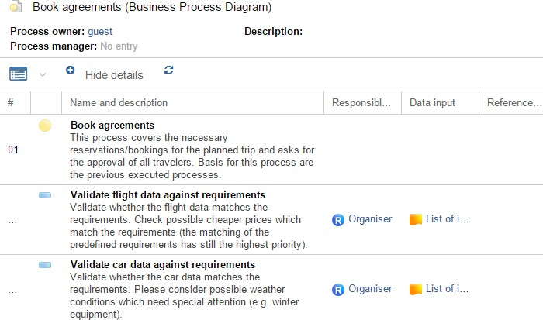

Fig. 35: Textual View of a Business Process

### Open Model in the Textual View

In order to open a model in the textual viewer, proceed as follows:

* + - Select the model you want to open in the Model Catalogue.
    - Right-click the model, point to *Open as*, and then click *Text*.

### Show/Hide Details

The *Descriptions* of the objects in the textual view can occupy much space. Therefore, they can be hidden from view. In order to show/hide the *Descriptions*:

* + - Click the *Show details* button respectively the *Hide details* button in the menu bar of the textual view.

### Sort Cells

By default, the view is sorted in the order of the objects (in ascending order). To change this sorting, proceed as follows:

* + - Click the header of a column to sort the table by its content (ascending).
    - Click on the column header again to reverse the sorting order from ascending to descending (and vice versa).

### Select Attributes

By default, various object attributes which are specified in the configuration are displayed. As this is in many cases too much information (and therefore not always significant), attribute columns can be hidden and shown as needed:

* + - The button is activated in the header of any column by mouseover. Click this button to open a drop-down menu.
    - Select the menu entry *Columns* or *Select attributes...* and choose the desired attributes from the submenu.



The attributes are arranged according to object type. Within the object type, the attributes are arranged according to the chapters of the Notebook of the object.

### Open Object Notebook

You can open the Notebook of an object in the textual view. Choose one of the following options:

* + - Click the name of the object or:
    - Right-click the object, and then click *Open*.



These options allow you to open the Notebooks of objects which are represented as table rows and objects that are referenced in attributes.

### Follow Reference

Depending on the configuration, objects in a textual view can include different kinds of references. In order to follow such an reference, e.g. to open the referenced model or object in a new tab:

* + - Click the name of an object which is flagged by the icon .

### Show in Graphical Editor

In order to view an object in the graphical editor in the context of its model:

* + - Select *context menu* of the object - menu entry *Show in graphical editor...*.

The model currently shown in the textual viewer opens in a new tab in the graphical editor. The selected object is highlighted on the drawing area.

## Large-Scale Editing of Attributes Using the Tabular Editor

The tabular model editor is a model viewing and editing tool. It presents objects as table rows, while the table columns hold their attributes. The model header above the open model contains basic information such as the name and description of the selected model.

Compared to the graphical editor, the tabular editor offers the opportunity to show the modelling content clear and well laid-out, even in large models. Attribute values can be edited quickly and extensively.

If an attribute cannot be found in the Notebook of an object, the corresponding cell is greyed out.

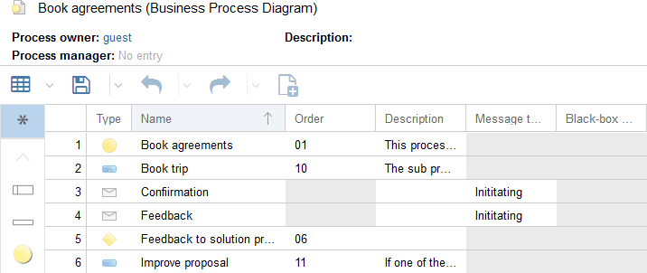

Fig. 36: Tabular Editor

### Open Model/Objects in the Tabular Editor

You can open both models and objects in the tabular editor:

Open Model in Tabular Editor

In order to open a model in the tabular editor, proceed as follows:

* + - Select the model you want to open in the Model Catalogue.
    - Right-click the model, point to *Open as*, and then click *Table*.

Open Objects in Tabular Editor

Alternatively, you can also open a selection of objects in the tabular editor:

* + - Select the objects you want to open in the Object Catalogue.
    - Right-click the objects, point to *Open as*, and then click *Table*.

### Edit Attribute Values

One of the advantages of the tabular editor is the possibility to change attribute values easily and straightforward.

Manually Edit Attribute Values

* + - Double-click a table cell to manually edit attribute values.

Delete Attribute Values

* + - Select one or more cells and press *<Del>*.

The existing values are replaced by the default values of the attributes.

Copy & Paste Attribute Values

Transfer attribute values between cells by *Copy & Paste*.

* + - Press *<Ctrl>* + *<C>* to copy an attribute value.
    - Press *<Ctrl>* + *<V>* to paste an attribute value.

The selected value may be pasted to one cell or multiple cells at once.



*Pasting* is only possible if the data in the clipboard match the data structure of the target attribute. For instance, numbers can be pasted into text attributes, but not text into numeric attributes.

Copy & Paste Multiple Values

* + - Use *Copy & Paste* to transfer multiple cells or whole rows within the tabular editor.

Pasting is executed via “best effort” approach i.e. pasting what is possible, ignoring what does not fit.

Copy & Paste From One Tabular Editor to the Other

* + - Use *Copy & Paste* to transfer attribute values to another tabular editor which is simultaneously open.

Copy & Paste From and to Other Applications

* + - Use *Copy & Paste* to import and export attribute values from and to other applications (e.g. Microsoft Excel).

### Select Cells/Rows

There are various methods via which you can select cells/rows for editing:

Select Cell

* + - Click a cell to select it.

Select Multiple Cells

* + - Click and hold the left mouse button and drag a frame around the cells or:
    - Press and hold *<Shift>* and use the arrow keys to select multiple cells.

Select Row

* + - Click the row header.

Select Range of Rows

* + - Click the first row header, press and hold the *<Shift>* key and click the last row header.

Select Different Rows

* + - Click the first row header, press and hold the *<Ctrl>* key and click additional row headers.

Select Whole Table

* + - Click on the top left (light grey) cell.
    - As an alternative, click a cell, and then press *<Ctrl>* + *<A>*.

### Sort Cells

By default, the view is sorted in the order of the objects (in ascending order). To change this sorting, proceed as follows:

* + - Click the header of a column to sort the table by its content (ascending).
    - Click on the column header again to reverse the sorting order from ascending to descending (and vice versa).

### Adjust Column Width

Many cells contain information too large to be visualised in a standard table view (e.g. long text). This will be indicated on the user interface:

* + - If the information is too long for the current cell width, the content ends in ellipsis (…).

There are two alternatives to optimize the column width:

Manually Adjust Column Width

* + - Drag the separator between the column headers to the left or right.

Automatically Adjust Column Width

* + - Double-click the column separator.

### Select Attributes

By default, various object attributes which are specified in the configuration are displayed. As this is in many cases too much information (and therefore not always significant), attribute columns can be hidden and shown as needed:

* + - The button is activated in the header of any column by mouseover. Click this button to open a drop-down menu.
    - Select the menu entry *Columns* or *Select attributes...* and choose the desired attributes from the submenu.



The attributes are arranged according to object type. Within the object type, the attributes are arranged according to the chapters of the Notebook of the object.

### Add and Remove Objects

In the tabular editor it is possible to create new objects or add existing objects from the Object Catalogue. It is further possible to delete superfluous objects.

Create Object

In order to create a new object:

* + - Click the corresponding object icon in the modelling bar to select the object type. The view is filtered.
    - Click the button in the menu bar of the tabular editor.

The object is created with a random name and the default attribute values and is added to the table as a new row.

When you create new objects in a model, they appear in the top left corner of the drawing area in the graphical editor.

Add Existing Objects

In order to add existing objects:

* + - Drag objects from the Object Catalogue into the tabular editor.



If you have opened a *model* in the tabular editor, the model type determines which object types you can add. In case of a *selection of objects*, you can add objects of any type.

Delete Object

In order to delete an object:

* + - Click the row header to select the object.
    - Right-click the row header, and then click *Remove*.

### Open Object Notebook

You can open the Notebook of an object in the tabular editor:

* + - Right-click the object, and then click *Open* or:
    - Double-click the object icon in the column *Type*.

### Filter View by Object Type

In order to only display objects of a certain type in the tabular editor:

* + - Click the corresponding object icon in the modelling bar.

In order to switch back to the overview of all object types:

* + - Click the *Show all* icon in the modelling bar.

### Export Table Content

The tabular model editor offers the possibility to save the visualised attributes from ADONIS NP to the file system as an Excel file (XLSX format).

In order to export the table content, proceed as follows:

* + - Click the *More* button in the menu bar of the tabular editor.
    - Point to *Export* , and then select the desired export configuration.

1. grouped:

A separate Excel sheet is created for each object type.

1. current view:

The appearance of the Excel spreadsheet corresponds to the display in the tabular editor.

## Search & Analysis

You can quickly search for specific models and objects using the search function of ADONIS NP. At the same time, you can perform a full-text search in all documents in the database.

The extended search options and filters allow you to seamlessly refine your search for structured analysis of your data and for your reporting.

### Quick Search

In order to execute a search:



Fig. 37: Execute Search

* + - Enter the search term into the input field in the upper-right corner.
    - Press *<Enter>*. The search function opens.

Optionally you can also:

* + - Use quotes to search for an exact set of words.
    - Directly open the search function without typing a search term. In order to do so, click the *Search* button in the navigation bar.

Search Results

The search results consist of:

* + - All models and objects containing the search term in their *Name* or *Description* and:
    - All documents in the database which contain the search term.

The models and objects are presented as table rows in the search results, while the table columns hold their attributes.

Depending on the Application Library and product configuration, a different set of attributes than *Name* and *Description* may be considered to find matching objects or models.

### Display Hits in Documents

In order to display hits in documents:

* + - In the search results, click the icon in the column *Referenced document*.

All hits in the document are listed in a separate dialogue along with their immediate context.

### Filter Results by Topic

In order to filter the search results so that only a topic-specific selection of model or object types is displayed:

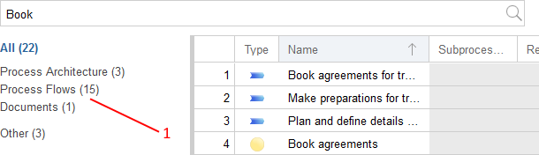

Fig. 38: Filter Search Results by Topic

* + - Click the corresponding topic in the list to the left of the search results (1).

In order to switch back to the overview of all topics:

* + - Click *All*.

**Example**

You are looking for a *Document*, but your search returns too many results. Proceed as follows:

* Enter the search string into the input field and press *<Enter>*.
* Select the topic *Documents* so that only *Document Models* and *Documents* are displayed in the search result.

Available Topics

* + - **Process Architecture**

Search for *Company Maps*, *Products* and *Processes*.

* + - Process Flows

Search for *Business Process Diagrams*, *Tasks*, *Exclusive Gateways*, *Start Events*, *Subprocesses* and *Intermediate Events (sequence flow)*.

* + - Documents

Search for *Document Models* and *Documents*.

* + - Organisation

Search for *Working Environment Models*, *Performers*, *Users*, *Organisational Units* and

*Roles*.

* + - Governance, Risk & Compliance

Search for *Control Objective Pools*, *Control Pools*, *Risk Pools*, *Users*, *Controls*, *Control Objectives* and *Risks*.

* + - IT

Search for *Use Case Diagrams*, *Data Models*, *IT System Models*, *Applications*, *Use Cases*, *Attributes*, *Entities*, *Infrastructure Elements*, *Operations*, *Interfaces*, *Services* and *System Boundaries*.

* + - KPIs & Initiatives

Search for *Initiatives*, *Performance Indicator Overviews* and *Performance Indicators*.

* + - Other

Search for models and objects, which are not covered in the above topics.

### From Search to Analysis

Use the extended search options and filters to narrow down your search results.

#### Refine Criteria

In order to refine your search:

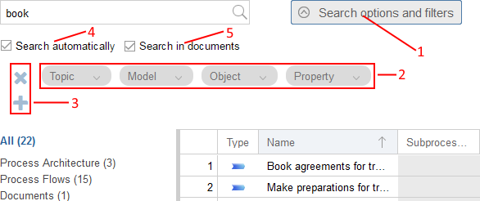

Fig. 39: Refine Search

* + - * Click the *Search options and filters* button (1). The search options and filters are displayed.
      * Select a filter like *Topic* or *Model* to narrow down your search results (2).

Optionally you can also:

* + - * Remove a filter by clicking the "x" icon included in the respective button.
      * Add or remove rows of filters by clicking the "+" and "x" icons (3).
      * Toggle *Search automatically* (4). If this checkbox is selected, ADONIS NP automatically adjusts the search results whenever you edit a filter.
      * Toggle *Search in documents* (5). Deselect this checkbox so that the search results are limited to only models and objects.

**Example**

You are looking for a *Business Process Diagram*, but your search returns too many results. Proceed as follows:

* Enter the search string into the input field and press *<Enter>*. The search results are displayed.
* Click the *Search options and filters* button. The search options and filters are displayed.
* Click the filter *Model* and select the model type *Business Process Diagram* from the drop-down list. Confirm with *Update*.

As a result, only *Business Process Diagrams* are displayed now. The search term may be contained in their *Name* or *Description*.

#### Available Filters for Data Analysis

The following filters are available:

Topic

Use this drop-down list to only display a topic-specific selection of model or object types in the search results. Additionally, you can display all models or all objects. For details please refer to the section Filter Results by Topic.

Model

Use this drop-down list to only display certain model types in the search results.

Object

Use this drop-down list to only display certain object types in the search results.

Property

Use this drop-down list to only display attributes which contain a specific attribute value in the search results. This process is broken into two steps:

1. First select an attribute from the drop-down list.
2. Then select, depending on the attribute type, an operator and a specific attribute value.

When defining the filter *Property*, the following operators may be used:

Available Operators

* + - * **Equals (****)**

Returns a match if the search value corresponds exactly to the attribute value.

* + - * Like (~)

Returns a match if the search value is contained in the attribute value.

* + - * Not Equals ()

Returns a match if the search value does not exactly correspond to the attribute value.

* + - * Greater ()

Returns a match if the search value is greater than the attribute value.

* + - * Greater or Equals ()

Returns a match if the search value is greater than or equal to the attribute value.

* + - * Smaller ()

Returns a match if the search value is smaller than the attribute value.

* + - * Smaller or Equals ()

Returns a match if the search value is smaller than or equal to the attribute value.

### Analysis without Search Term

You can analyse the models and objects saved in the database without entering a search term. In order to do so:

* + - Select any of the filters *Topic*, *Model type* or *Object type* to display all models/objects of a type.
    - Select the filter *Property* to display all attributes of a type which contain a specific attribute value.

**Example**

To display a list of all *Business Process Diagrams* in the database, proceed as follows:

* Do *not* enter a search term.
* Click the filter *Model* and select the model type *Business Process Diagram* from the drop-down list. Confirm with *Update*.

### Search in Documents only

You can search so that the search results are limited to only hits in documents in the database. In order to do so:

* + - Click the filter *Object* and select the object type *Document* from the drop-down list. Confirm with *Update*.
    - Click the filter *Property* and select the checkbox *Referenced document* in the chapter

*General information*. Confirm with *Assign*. A dialogue window opens.

* + - Select the operator *:*, and then enter the search term. Confirm with *Update*. All documents which contain the search term are now displayed.

### Combine Filters

You can combine multiple filters to create complex queries.

Add Multiple Conditions to a Filter

When you specify a filter, you can select multiple conditions from the respective drop-down list. The search result contains all elements that match at least one condition (logical OR operator).

Combine Multiple Filters within a Row

You can combine multiple filters in a row to narrow down the search results. The search result contains only elements which meet all conditions set in this row (logical AND operator):

* + - Choosing a topic determines which model/object types are available.
    - Choosing a model type determines which object types and model attributes are available.
    - Choosing an object type determines which object attributes are available.

**Example**

You want to know which *Business Process Diagrams* are identified as *Key Processes*. Proceed as follows:

* Click the filter *Model* and select the model type *Business Process Diagram* from the drop-down list. Confirm with *Update*.
* Click the filter *Property* and tick the checkbox *Key process* in the chapter

*Classification*. Confirm with *Assign*. A dialogue window opens.

* Tick the checkbox *Yes*. Confirm with *Update*.

As a result, only *Business Process Diagrams* identified as *Key Processes* are displayed now.

Combine Multiple Rows of Filters

You can combine multiple rows of filters. The search result contains all elements that match the conditions specified in any row (logical OR operator).

**Example**

You want to simultaneously list all *Risks* which have a very high impact and all *Controls*

which benefit from automatic controls. Proceed as follows:

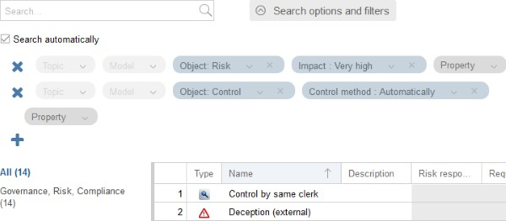

Fig. 40: Combine Multiple Rows of Filters

* Click the filter *Object* and select the object type *Risk* from the drop-down list. Confirm with *Update*.
* Click the filter *Property* and tick the checkbox *Impact* in the chapter *Risk assessment*. Confirm with *Assign*. A dialogue window opens.
* Tick the checkbox *Very high*. Confirm with *Update*. All *Risks* which have a very high impact are now displayed.
* Add a row of filters by clicking the "+" icon.
* Click the filter *Object* and select the object type *Control* from the drop-down list. Confirm with *Update*.
* Click the filter *Property* and tick the checkbox *Control method* in the chapter *General information*. Confirm with *Assign*. A dialogue window opens.
* Tick the checkbox *Automatically*. Confirm with *Update*. Additionally to the *Risks*

now all *Controls* which benefit from automatic controls are also displayed.

### Clear Search Results

In order to clear the search results:

* + - Click the *Create a new search* icon ( ).

### Save Search Query

In order to save a search query:

* + - Click the *Save current search query...* icon .

Alternatively, you can create a copy of an already saved search query:

* + - Click the *Save current search query with a new name...* icon .

### Manage Stored Search Queries

In order to manage your stored search queries:

* + - Click the *Manage stored search queries...* button .

A support dialogue opens. The following functions are available:

* + - Select a query and click the *Execute* button to execute it.
    - Select a query and click the *Delete stored query* icon to delete it.
    - Click the *Close* button to close the dialogue.

### Export Search and Analysis Results

In order to export the search results as an Excel file (XLSX format):

* + - Click the *Export* button .
    - Select the desired export configuration from the drop-down menu.

1. grouped:

A separate Excel sheet is created for each topic.

1. current view:

The appearance of the Excel spreadsheet corresponds to the display in the tabular editor.

## Usage Analysis

The usage analysis functions allow you to display references of models and objects, help finding broken references and let you quickly find out in which models an object is used.

### Display References

References provide the possibility to cross-reference between objects, between models or between objects and models. For example, a *Task* in a *Business Process Diagram* can need a certain *Document* from a *Document Model*.

As references can often result in complex reference trees and networks, ADONIS NP allows you to display all references of a model or object and find out whether these references are valid or broken.

References are created and managed in the Notebook of the objects/models. Please refer to the section Manage Relations for details.

Display References

To display the references of a model or object, proceed as follows:

* + - Select a model or object (multiple selection is possible).
    - Right-click the selection, point to *Usage analysis*, and then click *References*.

The references dialogue opens.

Structure of the References Dialogue

The references dialogue shows all incoming and outgoing references in a tree:

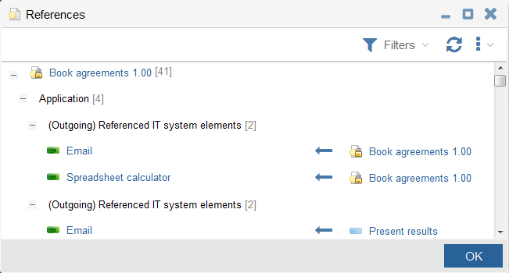

Fig. 41: Reference Dialogue

The following information is displayed:

* + - The top level contains a node for each model, for which references are displayed (only in case of model references).
    - The next level contains all object and model types which are referenced. The numbers in parentheses indicate in how many concrete objects/models the reference is really used.
    - The next level contains the type of reference.
    - The final level contains the referenced model or object. Additional columns show the source model/object of the reference (for outgoing references) or the target model/ object (for incoming references).
    - For every reference you can see whether it is valid or broken (e.g. because the target model or object was deleted, icon ).

**Example**

The view above e.g. shows that the object *Spreadsheet calculator* of the type *Application* is referenced in the attribute *Referenced IT system elements* of the model *Book agreements 1.00*.

Filters

In order to display only certain references:

* + - Click the button .

You can show or hide incoming, outgoing, broken and valid references.

Follow Reference

In order to follow a reference:

* + - Click the reference in question.

The referenced model is opened (if currently closed) and activated in the workspace. In case of an object reference, the Notebook of the object is opened instead.

### Display Object Usage in Models

To quickly find out in which models an object is used, proceed as follows:

* + - Select an object, e.g. in the Object Catalogue or on the drawing area.
    - Right-click the selection, point to *Usage analysis*, and then click *Usage in models...*.

As a result, all models in which the selected object is used are listed in a dialogue window.



This option is only available for repository objects, because modelling objects cannot be reused in different models.

Open Model

In order to open a model from the list:

* + - Select the model in question.
    - Click *Open*.

### Display Usage Overview of Object

To display a usage overview of an object, proceed as follows:

* + - Select one or more objects in the Object Catalogue.
    - Right-click the selection, point to *Usage analysis*, and then click *Usage overview*.

The usage overview opens. The objects are grouped by object type. For every listed object you can see at a glance if it is referenced respectively if it is used in one or more models (icon ) or not (icon ).

Open Object Notebook

In order to open the notebook of an object from the list:

* + - Click the object in question.

## Collaboration

This chapter provides an overview of the most important collaboration functions of ADONIS NP.

### Show/Hide "Collaboration" Widget

The "Collaboration" widget is located at the right side of the program window. You can use it to both read comments by your colleagues and create your own comments on models and objects. Depending on the Application Library and product configuration, the "Collaboration" widget is either visible or hidden at program startup.

Show "Collaboration" Widget

In order to show the "Collaboration" widget:

* + - Click the *Collaboration* button .

Hide "Collaboration" Widget

In order to hide the "Collaboration" widget:

* + - Click the *Collaboration* button again.

Additionally, you can switch to the validation functions.

Switch between Collaboration and Validation

* + - Click the button *Collaboration* situated on the upper left corner of the "Collaboration" widget.
    - Select the menu entry *Validation*.

### Subscribe/Unsubscribe to Comments

In ADONIS NP, you can only see comments on your favourite models or objects. This means you are only shown comments that you are actually interested in.

Subscribe to Comments

In order to subscribe to comments on a model or object, you have to add it to your favourites:

* + - Right-click the model or object, and then click *Add to favourites*.





Your favourite models and objects are marked by a star icon ( ) in the Explorer.

Unsubscribe from Comments

In order to unsubscribe from comments on a model or object, you have to remove it from your favourites:

* + - Right-click the model or object, and then click *Remove from favourites*.

### Create Comment

In order to create a comment on a model or object:

1. Either open the model or open the Notebook of the model or object.
2. Type your comment directly in the text field at the bottom of the "Collaboration" widget.
3. Click the *Create* button .

Additionally, you can:

* + - Click the *Upload file* icon to attach a file to your comment.
    - Click the *Remove file* icon to cancel uploading a selected file.
    - Click the *Create Model/Object Link* icon to add a link to a model or object to your comment. Alternatively, you can select a model/object in the Explorer and insert it in the comment by *drag and drop*.



When you create a comment you automatically subscribe to comments on the selected model or object.

#### Special Case: Create Model Comment with Open Questions

In order to create a model comment with open questions:

* + - * Right-click the model in the Model Catalogue, point to *Reports*, and then click *Create model comment with open questions*.

This function creates a report which lists all objects in the selected model that contain open questions. This report is then attached to a new comment on the model which you can further edit before you confirm it.

When you execute this function you automatically subscribe to comments on the selected model.

### Post Reply

In order to post a reply to a comment:

* + 1. Select the comment in the "Collaboration" widget.
    2. Type your reply directly in the text field at the bottom of the "Collaboration" widget.
    3. Click the *Create* button .

Your reply is posted as an indented sub-comment.



The total number of replies is displayed on the bottom left of the comment. Click the respective icon to expand/collapse all sub-comments.

### Filter Comments

You can set up a comment filter in the menu bar of the "Collaboration" widget:

* Select the *Favourites* icon to show comments on all your favourite models and objects.
* Select the *Current model or object* icon to only show comments on the currently selected model or object.

### Search in Comments

The search function is offered as an input field in the menu bar of the "Collaboration" widget.

Execute Search

In order to execute a full-text search across the current selection of comments:

* Enter the search string into the input field.
* Press *<Enter>* or click the *Search* icon ( ).

All comments that contain the search string are shown. If the search string is included in a sub-comment, its parent is shown as well.

Clear Search Filter

In order to clear the search filter:

* Click the *Clear search filter* icon ( ).

### Show New Comments

ADONIS NP provides a notification when new comments are posted to your favourite models or objects.

In order to show new comments:

* Click the linked model in the callout.

New comments are marked by a blue dot icon ( ).

## Validation

The validation functions in ADONIS NP allow you to check whether models and objects comply to the modeling guidelines. If the modeling guidelines are violated, ADONIS NP shows corresponding notifications.

**Examples of Modelling Guidelines**

* Each *Business Process Diagram* should have at least one *Start Event* and one

*End Event*.

* *Tasks* should be named in an active way by using a combination of verb and object,

e.g. "Pay bill" or "Send documents".

There are several check categories, which, in turn, consist of one or several individual checks.

The provision of check categories and individual checks depends on the configuration of your ADONIS NP installation. They can be configured in the ADONIS NP Administration Toolkit.

### Run Checks

You can either run all checks at once or run checks by category:

* + 1. Select a model or object (multiple selection is possible).
    2. Right-click the selection, point to *Validation*, and then click either *All* or *By category...*.
    3. In case you chose *By category...* in step 2, a dialogue is displayed. Select one or more categories and confirm with *OK*.

The "Validation" widget opens at the right side of the program window. The checks are run and the results are displayed.

### Navigate through Results

ADONIS NP displays the results of the checks on a separate page for each model or object.

Within a page, the results are grouped by category (e.g. *BPM Best practice*) and then type of notification (e.g. *Error* or *Warning*).

Errors are marked red. If a page contains errors, the page title is marked red as well.

In order to navigate through the results:

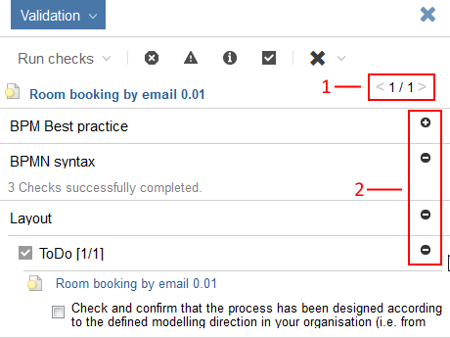

Fig. 42: Navigate through Results

* Click the < and > arrows to switch between models/objects (1).
* Click the and icons to expand or collapse categories and types of notifications (2).

### Filter Results

In order to filter the results of the checks:

* Click the buttons , , or .

You can show or hide errors, warnings, notes and ToDos.

### Display Full Text of Notification

In order to display the full text of a notification:

* Double-click the notification or:
* Hover with the mouse pointer over the notification.

### Display Model/Object

In order to display the model or object to which a notification refers:

* Click the title of the notification.

The model is opened (if currently closed). If an object is selected, it is highlighted in the model.

### Mark ToDo as Completed

ToDos are checks which have to be verified manually. If your check yields a positive result, you can mark the ToDo as completed. In order to do so:

* Select the checkbox within the notification.

The checked state is saved and will be visible to all users in the "Validation" widget.

### Fix Error Automatically

ADONIS NP can fix certain errors automatically. In order to do so:

* Click *Fix automatically* within the notification.

### Fill Mandatory Attributes

ADONIS NP provides a warning when not all mandatory attributes of an object have been filled. The affected attributes are listed in the notification. In order to fill a mandatory attribute:

* Click the attribute in question.

The Notebook of the object opens. You jump directly to the selected mandatory attribute.

### Remove Models/Objects

In order to remove a model or object from the "Validation" widget:

* Click the *Remove* button .

In order to remove *all* models and objects:

* Click the down arrow symbol ( ) in the *Remove* button.
* Select *Remove all* from the drop-down menu.

### Exit Validation

You can either hide the widget or switch to the collaboration functions.

Hide "Validation" Widget

In order to hide the "Validation" widget:

* Click the icon .

Switch between Validation and Collaboration

* Click the *Validation* button.
* Select the menu entry *Collaboration*.

## Model Comparison

The graphical comparison of models makes the differences between two models visible. This includes deleted objects and connectors, new objects and connectors as well as changes in the attribute values. Thereby it is possible to highlight the differences in e.g. two versions of one process. If you have sufficient user rights, you can also edit the models.

In addition, all differences are listed in detail in a table. This table can be exported as an Excel file (XLSX format).

### Start Comparison

In order to compare models:

* Select the first model in the Explorer. This model represents the state of the model before changes. On the UI it is called the *base model*.
* Press *<Ctrl>* and select the second model in the Explorer. This model represents the state of the model after changes.
* Right-click the selected models, and then click *Compare*. The model comparison opens.

Additionally, you can:

* Click the *Enter fullscreen mode* button to expand the graphical model comparison to fill the entire browser window.

Comparison with Predecessor Model

Additionally, you can directly compare a versioned model with its predecessor model:

* Open the model in the graphical editor.
* Click the button in the menu bar of the model.
* Select the menu entry *Compare* .

The model comparison opens. The predecessor model is assigned as the *base model*.



Click the *Comparison* button again to compare the predecessor model with the

*pre-predecessor* model etc.

### Results of the Model Comparison

The result of the comparison is displayed as follows:

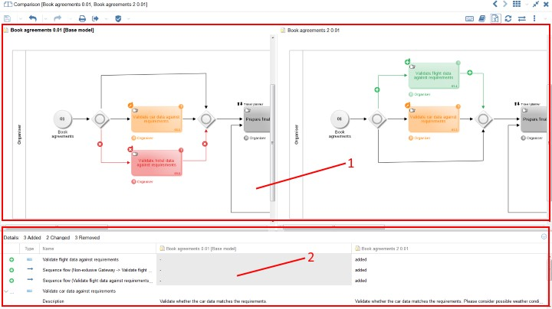

Fig. 43: Model Comparison

* The two models are opened in side by side model windows in the graphical editor (1). Differences between the models are highlighted. The *base model* is always on the left side.
* The results of the model comparison are simultaneously displayed in a table (2).

Graphical Model Comparison (1)

Differences between the models are highlighted as follows:

* Grey

The object or connector is identical in both models.

* Red (icon )

The object or connector only occurs in the left model (the *base model*). It was *removed*

from the newer model on the right.

* Green (icon )

The object or connector only occurs in the right model. It was *added* to the newer model on the right.

* Orange (icon )

The object or connector has different attribute values in the two models. Hover the mouse pointer over the element to display a tooltip with information about the changes.

Tabular Model Comparison (2)

The results of the model comparison are displayed as follows in the table:

* The table header contains a summary of the changes.
* Objects and connectors are presented as table rows, while the table columns list the differences.
* Removed (icon ), added (icon ) and changed (icon ) objects or connectors are shown.

### Switch Base Model

In order to switch the *base model*:

* Click the *Switch base model* icon in the menu bar of the model.

### Switch Active Model

The menu bar is shared between both model windows. Some of the functions which can be accessed through the menu bar are specific to the active model.

The active model is the model which is currently being edited. It can be identified by its title which is displayed in bold. In order to switch the active model:

* Click anywhere on the drawing area in the inactive model.

### Refresh Results

When you edit one of the models, the *Refresh* icon and the title of the model comparison become red. This indicates that the current view is outdated. In order to refresh the view:

* Click the *Refresh* icon in the menu bar of the model.

### Navigate through Results

There are different options to navigate through the results:

Synchronized Scrolling and Zooming

Scrolling and zooming is synchronized between the two model windows:

* When scrolling through the content of one of the models or changing the zoom factor, the corresponding change is mirrored in the other model.

Connection between the comparison table and the model windows

The comparison table and the model windows are connected as follows:

* When you click a cell, the according object or connector is displayed centred and marked red in the model window.

Open Notebook from Comparison Table

In order to open the Notebook of an Object or Connector in the comparison table:

* Double-click a cell to open the notebook of the corresponding object or connector.

### Export Results

In order to export the comparison results as an Excel file (XLSX format):

* Click the *Export* icon .

In the Excel spreadsheet, removed , added and changed objects or connectors are shown.

## Working with Views

The following sections provide an overview of the most important functions for working with views.

### Available Views

Views in ADONIS NP enable the user to visualize and modify dependencies between objects. They can be generated using the following starting points:

* Reporting Board
* Model Catalogue
* Object Catalogue
* Graphical editor
* Tabular editor
* Textual view
* Query result
* Reference entry within a Notebook
* Opened views in ADONIS NP

There are five types of views in ADONIS NP:

* *Matrix View*
* *Portfolio View*
* *BIA View (Dependency Analysis)*
* *Gantt View*
* *Cluster Map*



All views provide the possibility to capture and / or maintain visualized elements and values. Changes are updated in the respective view immediately. If relations are modified between the displayed objects the view can be refreshed by clicking *Update all relations* in the context menu.

The provision of views depends on the configuration of your ADONIS NP installation. Further views can be configured in the Administration Toolkit.

#### Visualize Relations of the Business Process Architecture with the Matrix View

The Matrix View is used to show explicit and implicit dependencies between core elements of businesses (e.g. processes, organizational units and roles, documents, applications, risks,

controls etc.). The Matrix View can be applied to visualise the connection of two levels of the metamodel. The links can be, for example, the inputs and outputs of processes or the controls that are associated with risks.

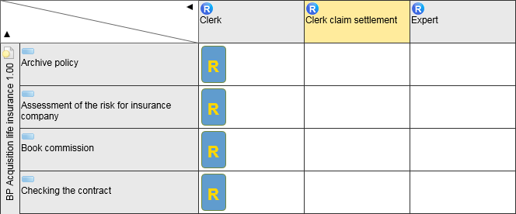

Fig. 44: Example of a Matrix View

#### Compare Objects with the Portfolio View

In a Portfolio View objects can be compared by using up to three attributes. For managing a portfolio the Portfolio View offers a concise way to evaluate portfolio elements.

A possible use case is the evaluation of controls based on effectiveness, method and execution or the evaluation of risks based on a FMEA.

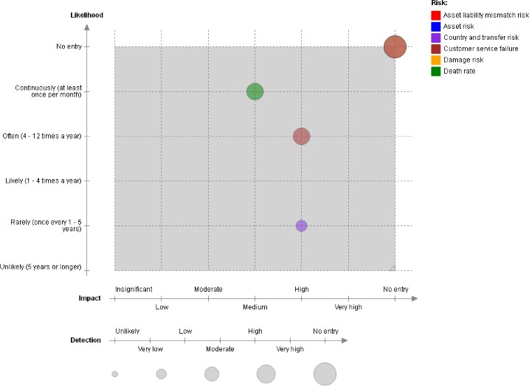

Fig. 45: Example of a Portfolio View

#### Visualise Cross-Layer Dependencies with the BIA View (Dependency Analysis)

The BIA (Dependency Analysis) facilitates the visualisation of (critical) connections and dependencies of individual elements of the process and enterprise architecture across multiple architectural layers. A possible use case is to show which risks and controls have direct or indirect impact on business processes and which control objectives are affected.

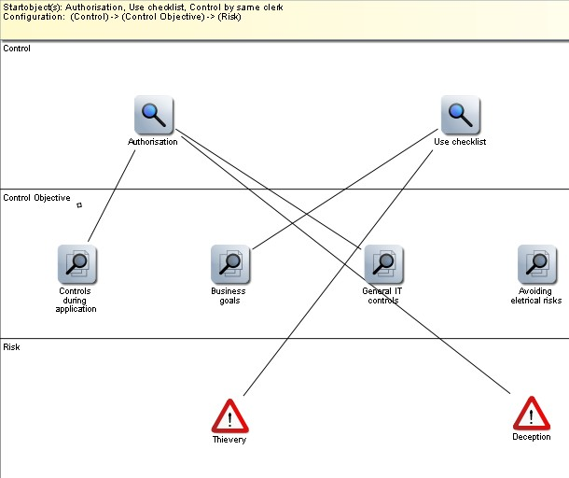

Fig. 46: Example of a BIA View

#### Compare Objects with the Gantt View

In a Gantt View single attributes of architectural objects can be compared, either directly or in an aggregated form. The Gantt View provides a quick orientation by using simple, intuitive data visualisation.

One possible use case is the visualisation of the lifecycles of processes or planning and controlling data of initiatives which are depicted as horizontal bars together with a timeline.

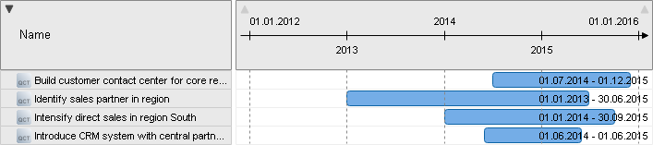

Fig. 47: Example of a Gantt View

#### Visualise Hierarchies and Relations between Objects in a Cluster Map

Cluster Maps in ADONIS NP visualise hierarchies and relations between objects. The cluster map must be configured in the Administration Toolkit before it is available in the web client. Many different hierarchies can be easily displayed in the corresponding model types using different configurations.

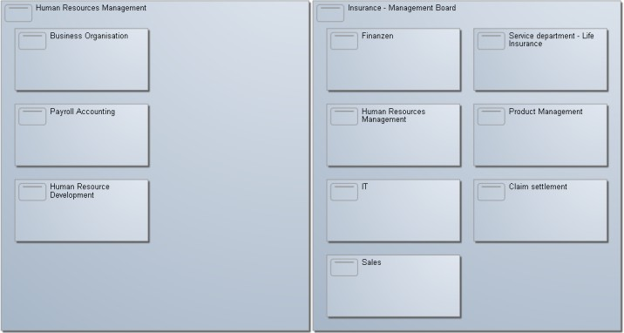

Fig. 48: Cluster Map

### The Matrix View

Follow these steps to create a Matrix View:

* + - Select the objects or the model to be displayed in the Matrix View.
    - Choose the desired Matrix View configuration. From the context menu, select *Create view* – *Matrix...* (selection criteria depend on both the selected objects and the options pre-configured in the Administration Toolkit).

The Matrix View is generated. The Matrix View will automatically add all objects which have a relation to the earlier selected objects according to the Matrix View configuration.

In addition to the standard view certain matrix configurations support additional viewing options.

#### Expand Matrix View Manually

* + - * Add additional objects of the same class at the respective axis by *drag and drop*.

#### Complete Matrix

There are two options to automatically complete a Matrix View:

* + - * Select *context menu* - *Complete matrix* and choose *for all objects* from the submenu.

The Matrix View will automatically add all objects which have a relation *to the currently visible set of objects* according to the Matrix View configuration.

* + - * Select *context menu* - *Complete matrix* and choose *for selected object* from the submenu.

The Matrix View will automatically add all objects which have a relation *to the selected object*

according to the Matrix View configuration.

#### Modify Relations between Objects

If relations between objects are being modified, all changes will become effective immediately in the corresponding objects. Depending on the type of the matrix there are several options for modifying the relations between the objects.

Matrix Views that contain modelling objects are read-only. You cannot edit the relations between the objects in such Matrix Views.

##### Modify Relations in a 3-dimensional Matrix

In a 3-dimensional matrix relational objects are displayed in the cells. You have the following options for modifying relations:

Add Cell Objects

* + - * + Add new objects to the Matrix View by *drag and drop* or via the context menu item

*Create <object type>*.

Delete Cell Objects

* + - * + Delete cell objects and also the corresponding objects on each axis via the context menu item *Remove from cell*.



All newly added or deleted relations are also added or deleted in the corresponding Notebooks of the affected object.

##### Modify Relations in a 2-dimensional Matrix

In a 2-dimensional matrix objects in a cell represent a relation between the objects on each axis. You have the following options for modifying relations:

Create Relation

* + - * + Select *context menu* - *Create relation*.

Remove Relation

* + - * + Select *context menu* - *Remove relation*.



All newly added or deleted relations are also added or deleted in the corresponding Notebooks of the affected object.

#### Change Visualisation

Rearrange the elements of the view upon predefined criteria:

* Click the *Change visualisation* button , and then select the desired visualisation.

Different values of an attribute which is shared by objects in a Matrix View can be displayed in a heat map. The values will be coloured and marked with a matching symbol according to the configuration to e.g. indicate the probability of the occurrence of a risk.

The responsibilities of various roles for each step in a process according to a RACI matrix can also be displayed in this way.

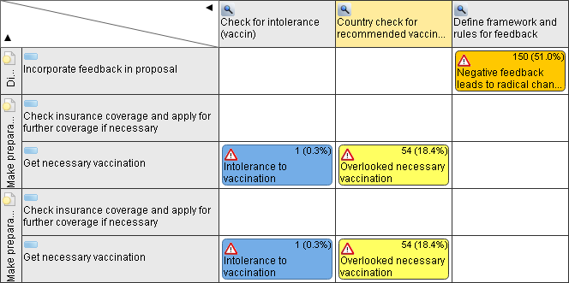

Fig. 49: A heat map



Heat map features are dependent on the Application Library and product configuration.

#### Adjust View

Adjust the view to display or hide columns and rows without cell objects. In a 3-dimensional Matrix View you can also highlight cell objects which occur multiple times:

* Click the button , and then select the desired setting.

#### Export View

In order to export the view as an Excel spreadsheet (XLSX format), PDF or image file (PNG format):

* Click the *Export view* button , and then select an export format.

### The Portfolio View

Follow these steps to create a Portfolio View:

* + - Select the objects or the model to be displayed in the Portfolio View.
    - Choose the desired Portfolio View configuration. From the context menu, select *Create view* – *Portfolio...*.

#### Expand Portfolio View

To manually expand the Portfolio View:

* + - * Add additional objects of the same class to the view by *drag and drop*.

New objects will be positioned according to the existing objects in the view.

#### Adjust View

Adjust the view to activate or deactivate tooltips, invert the x-axis and y-axis and to display or hide the legend and bubble slices.

* + - * Click the button , and then select the desired setting.

#### Export View

In order to export the view as an Excel spreadsheet (XLSX format), PDF or image file (PNG format):

* + - * Click the *Export view* button , and then select an export format.

### The BIA View (Dependency Analysis)

Follow these steps to create a BIA View:

* Select the objects or the model to be displayed in the BIA View.
* Choose the desired BIA View configuration. From the context menu, select *Create view* – *BIA...*.

### The Gantt View

Follow these steps to create a Gantt View:

* Select the objects or the model to be displayed in the Gantt View.
* Choose the desired Gantt View configuration. From the context menu, select *Create view* – *Gantt...*.

#### Expand Gantt View

To manually expand the Gantt View:

* + - * Add additional objects of the same class to the view by *drag and drop*

The new objects will be added at the bottom of the view.

#### Adjust View

Adjust the view to activate or deactivate tooltips and to display or hide attribute values.

* + - * Click the button , and then select the desired setting.

Similarly, in the Gantt View, alphabetical sorting and sorting by the attribute values is possible:

* + - * Click the arrow icon in the header of the column you want to sort by.

#### Export View

In order to export the view as an Excel spreadsheet (XLSX format), PDF or image file (PNG format):

* + - * Click the *Export view* button , and then select an export format.

### The Cluster Map

Follow these steps to create a Cluster Map:

* + 1. Select the objects to be displayed in the Cluster Map or the model template (= the source model).
    2. Open the context menu and select *Create view* – *Cluster Map...*. A dialogue window opens.
    3. Select the desired Cluster Map *configuration* from the drop-down list.
    4. Confirm with *OK*.

Optionally you can also:

* Adjust the evaluation path of the Cluster Map.
* Use a model template.

#### Adjust Evaluation Path

When you select objects (e.g. in a model or in the Object Catalogue) and generate a Cluster Map, you can adjust the number of displayed objects.

Cluster Maps with a *reduced evaluation path* decrease the number of displayed objects. Only objects that have a relation to the earlier selected objects are displayed. This relation must be defined in the Cluster Map configuration.

Cluster Maps with a *reduced evaluation path (top down)* decrease the number of displayed objects even further. Only objects that both have a relation to the earlier selected objects and are lower in the hierarchy of the Cluster Map are displayed.



The provision of path evaluation options depends on the configuration of your ADONIS NP installation. They can be configured in the Administration Toolkit.

#### Use Model Template

The option „*Use model template*“ can be activated when generating a Cluster Map. The selection of a template enables you to represent the objects in the Cluster Map according to a specific graphical structuring. When you generate a Cluster Map on a model that is already the case. Therefore, this option is only available when you generate a Cluster Map on an object.

#### Create Model Template

Set a specific layout for a cluster map with a model template. To do this you have to be familiar with the Cluster Map configuration. In order to create a model template:

* + - 1. Create a new model with a meaningful name. Select the model type according to the configuration. Usually this should be the *Analysis Model*.
      2. Place all objects of the first layer which should be displayed in the Cluster Map on the drawing area. To do this use *drag and drop* from the Object Catalogue. Select the object type according to the configuration.
      3. *Double-click* the objects on the drawing board to open their Notebooks.
      4. In the chapter "Representation", *deactivate* the option *Display as Icon*. The objects will now appear on the drawing area as rectangles of modifiable size.
      5. Adjust the size and alignment of the objects to specify the layout you have in mind.
      6. Click the *Save* button in the menu bar of the open model.

Optionally you can also:

* Repeat steps 2 - 5 for the objects of the layers below the first layer, if you want to set a specific layout for them as well. Place the objects entirely on those objects of the layer above they have a relation with according to the configuration.



Only place objects of the layers below the first layer, if they have a relation to other objects in the model template which is defined both in their notebooks and the configuration.

## Reporting Board

The Reporting Board allows you to create different reports (= views and PDF reports) from one central dashboard. There are several report categories (e.g. *Business Scenario* or *Type*). Each category, in turn, consists of one or more groups of individual reports.

The provision of report categories depends on the configuration of your ADONIS NP installation. Report categories can be configured in the ADONIS NP Administration Toolkit.

### Open Reporting Board

In order to open the Reporting Board:

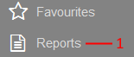

Fig. 50: Open Reporting Board

* + - Click the *Reports* button (1) in the navigation bar.

### Choose Category

In order to choose a category:

* + - Click the category selection button on the top left of the Reporting Board, and then select a category from the dropdown-list.

### Create Reports

In order to create reports:

1. Click the tile representing the report you want to create. A dialog box opens.
2. Select the models or objects you want to create a report on, and then click *OK*.

Optionally you can also:

* + - Click the *Create empty* button to create an empty report.

Select Models/Objects in Explorer

Alternatively, you can create reports with the Explorer as the starting point:

1. Select the models/objects you want to create a report on in the Explorer.
2. Drag the items to the appropriate tile on the Reporting Board.

## Publishing

This chapter provides an overview of the most important publication functions of ADONIS NP.

### Create Report

You can create various PDF and CSV reports based on models or objects. These reports

* 1. provide an overview of the values of certain attributes across all the selected elements. In order to create a report:
     1. Select the models/objects you want to create a report on.
     2. Select *context menu* - *Reports* and choose the desired report from the submenu. The settings dialogue opens.
     3. Select the desired *report options*.
     4. Confirm with *OK*.



You can create reports this way using e.g. the Explorer, the textual view or the graphical editor as a starting point. Additionally, it is possible to create reports from various widgets and dashboards by clicking the appropriate icon.

Different kinds of reports are available depending on your Application Library and product configuration.

#### Report Options

The following report options are available:

Page layout

During ADONIS NP configuration different page layouts for reports can be defined. These layouts determine e.g. the appearance of the header and footer.

Content filter

The options in this area affect the content of the report. They are only displayed when creating a standard report.

* + - * Reduced report (only general information)

If you activate this option, the standard report lists only the *Name* and *Description* of contained objects.

* + - * Full report (consider all properties)

If you activate this option, the standard report lists all filled attributes of contained objects.

* + - * Include empty attributes

Activate *Include empty attributes* to display all attributes with no value in the report.

#### Available Reports

The following reports are available:

Standard Report

This report provides an overview of the selected models. It lists the model attributes and contains the model graphics. Additionally, the objects in the models are listed. In the case of *Business Process Diagrams*, *Company Maps* and *Working Environment Models* the objects are sorted by their order, else according to their type.

Open Questions Report

The main objective of this report is to provide an overview of the objects contained in the selected models which contain open questions. Models are sorted according to their type, and for every model all objects with open questions are listed.

Project Summary Report

This report provides a management summary for the selected project, considering the current state of models. The current state of the models in scope of the project is shown graphically and further details giving an overview of the current progress are provided.

QM Report

For the generation of a QM report one or more *Business Process Diagrams* must be selected. The model graphic is shown and a selection of model attributes is listed. Additionally, the objects in the model including their attributes are listed.

Object Report

This report provides an overview of the selected objects. The objects are sorted according to type and the object attributes are listed.

The described configuration refers to the ADONIS BPMS Application Library and can differ from your configuration.

#### Reporting Overview

The Reporting Overview allows you to track the state of the reports you are currently generating in an overview window. It lists all reports that are queued (*Pending...*) or being generated (*Processing...*). When a report is completed, it will be downloaded automatically.

Open Reporting Overview

In order to open the Reporting Overview:

* + - * Click the *Reporting overview* button at the top right corner of the program window.

Cancel Report

In order to cancel a report:

* + - * Click the *Cancel* button .



The total number of reports currently being generated is displayed within the

*Reporting overview* button.

### Print Model

Models in the graphical editor can be printed as a PDF document. You can save this document on your computer, share it with colleagues or print it on paper.

In order to print a model to PDF:

* + 1. Click the *Print* button in the menu bar of the open model. The print dialogue opens.
    2. Select the desired *print options*.
    3. Confirm with *Print*.

#### Print Options

The following print options are available:

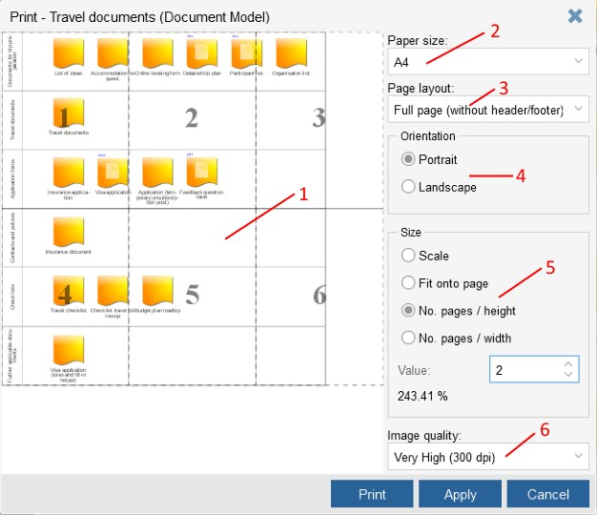

Preview (1)

Fig. 51: Print Options

The left part of the dialogue contains a print preview. This preview complies with the settings of the right part of the dialogue window.

* + - * Page selection

To omit particular pages during printing, click them in the preview window. They will be highlighted and omitted during printing. You can un-mark pages by clicking them again.

Paper size (2)

The setting *Paper size* determines whether the document shall be printed in an *A1*, *A2*, *A3*, *A4*, *A5*, *B4*, *B5* or *C5* format.

Page layout (3)

During ADONIS NP configuration different page layouts can be defined to supplement the model printouts. These layouts can contain logos, text, meta information like the user name and printing timestamp and much more.

Orientation (4)

The setting *Orientation* determines whether the document shall be printed in *Portrait* or

*Landscape* orientation.

Size (5)

Models need not always be printed in a standard size, but can be scaled to meet your needs when printed. The following sizing options are available:

* + - * Factor

The model is printed with a defined zoom factor, ranging from 1% to 400%. Default: 100% (the original size).

* + - * Fit onto page

The model is scaled to exactly fill one printing page. The necessary zoom factor is calculated automatically.

* + - * No. pages / height

The model is scaled to fill the printing pages determined in height. Factor and width in pages are calculated automatically.

* + - * No. pages / width

The model is scaled to fill the printing pages determined in width. Factor and height in pages are calculated automatically.

Image quality (6)

The setting *Image quality* determines whether the document shall be printed at 72, 150 or 300 dpi.

#### Save Model-Specific Print Options

You can save the print options that you defined for a specific model. In order to do so:

* + - * In the *print options* dialog box, click the *Apply* button.
      * Click either the *Print* or *Cancel* button.
      * Click the *Save* button in the menu bar of the model.

### Generate Image

Models in the graphical editor can be exported as graphic files (in PNG format). You can use these graphical model views in other applications than ADONIS NP (e.g. in a word processor).

In order to generate a graphic:

1. Click the *More* button in the menu bar of the open model.
2. Select the menu entry *Generate image...* . The settings dialogue opens.
3. Select the desired *graphic options*.
4. Confirm with *Generate image*.

Optionally you can also:

* Crop the image. Press and hold *<Ctrl>*, *<Shift>* and the left mouse button and drag a frame around the part of the model which shall appear in the graphic file.

#### Graphic Options

The following graphic options are available:

Preview

The left part of the dialogue contains a preview.

* + - * Display Detail

The part of the model which shall appear in the graphic file is visualised by a coloured border (by default the whole model).

Scale

The graphic is generated with a defined zoom factor, ranging from 1% to 400%. Default: 100% (the original size). After selecting a factor, the expected graphic size (in mm) is calculated and displayed.

Image quality

The setting *Image quality* determines whether the graphic shall be generated at 72, 150 or 300 dpi.

## Translation

The following sections provide an overview of functions for translating models and objects in the database.

### Start Translation

In order to translate models or objects:

* + - Select the models or objects you want to translate in the Explorer.
    - Right-click the selection, and then click *Translate* .

The translation editor opens.

### Structure of the Translation Editor

The translation editor is a specialised tabular editor, designed for translating models and objects in the database quickly and efficiently or for updating existing translations.

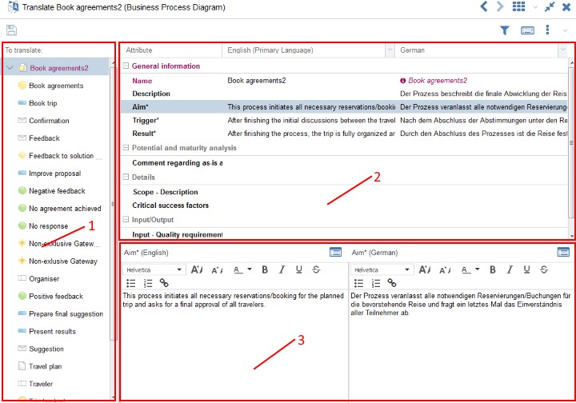

Fig. 52: Example: Translation of Several Models in the Translation Editor

The translation editor is structured as follows:

Model/Object Selection Widget (1)

The elements selected for translation – either models including their objects (when translating models) or objects (when translating objects) – are displayed as a hierarchical tree structure.

* + - Models or objects that contain attributes which have to be translated are highlighted. This facilitates recognising necessary translations.

Select a model or object from the tree to browse its attributes in the Attribute Selection Widget (2).

Attribute Selection Widget (2)

All attributes of the currently selected model or object which are relevant for translation are displayed in a table structure.

* + - Every row of this table represents a single Notebook chapter or attribute.
    - The first table column contains the name of the element.
    - The second column contains the text in the *Primary Language* (as defined in the Application Library) by default.
    - The third column contains the text in another language.
    - Table entries which are highlighted and marked by an indicator icon ( ) have to be translated: The content in this cell is older than the text in the *Primary Language*.
    - If a cell has to be translated, the name in the first column of the row as well as the parent Notebook chapter are highlighted too. This facilitates recognising necessary translations.

Select an attribute from the table to translate it in the Content Translation Widget (3).



The *Primary Language* is the language which is defined as a the main language in the Application Library.

Content Translation Widget (3)

The actual translation of the selected attribute takes place in this widget. For single-line text attributes the new value can be entered into a text field. For translating multiline attributes rich text editing support is available.

### Translate Content

In order to translate content in the translation editor:

1. Select a model or object from the tree view to browse its attributes.
2. Select an attribute from the table to translate it.
3. Enter the translation in the appropriate text field.
4. Confirm by clicking the *Save* button in the menu bar of the translation editor.

Besides translating text, you can also:

* + - Set up language specific links.
    - Make documents available in different language versions. In order to so, click the

*Upload file* icon .



Once you have edited a highlighted entry, it is marked as translated (= not highlighted anymore). This also applies to its parent elements unless they still contain other children which have to be translated.

#### Select Languages for Translation

In order to select which languages are displayed in the translation editor:

* + - * Click the button in the header of the column of which you want to change the language.
      * Select the desired language from the drop-down list.



This function is especially useful when three or more languages are in use. It allows you to translate between any two of them.

#### Navigation Shortcuts

Content in the tree can be shown or hidden by clicking the “+” and “-“ icons next to the elements. The following additional options are available:

* + - * Switch between Tree and Attributes

Press *<Ctrl>* + *<Enter>*.

* + - * Expand/Collapse Selected Node

Press *<Ctrl>* + *<Left Arrow/Right Arrow>*.

* + - * Navigate in Tree/Attributes

Press *<Ctrl>* + *<Up Arrow/Down Arrow>*.





Click the button in the menu bar of the translation editor to open an overview of all available keyboard shortcuts of the translation editor.

#### Get Write Access

Models and objects only allowing read access are marked by a small lock icon ( ). This is

* 1. the case if they are currently being edited by another user when you start the translation. In order to try to get write access to these elements later:
     + Select the locked model or object from the tree view. Instead of the attributes of the selected element an information message is displayed.
     + Click the highlighted link to try to get write access.

#### Filter Translated

In order to only display elements that need to be translated in the translation editor:

* + - * Click the button in the menu bar of the translation editor.

As long as the filter is active, elements which are marked as translated are not shown in the translation editor.

#### Automatically Translate Content

In order to automatically translate models and objects:

* + - * Click the icon in the menu bar of the content translation widget. A dialogue window with a translation proposal opens.
      * Confirm with *OK* to accept the proposal.



The availability of this function depends on configuration of your ADONIS NP installation.

## Interfaces

Using the ADONIS NP interfaces data can be imported from other applications into ADONIS NP and exported from ADONIS NP into other applications.

### Import Objects from Excel

ADONIS NP provides a configurable Excel interface for quick data acquisition. Via the Excel interface, you can import or update objects and their attributes from an Excel spreadsheet. The structure of the Excel spreadsheet is described in a freely configurable XML file in the Administration Toolkit.

In order to import objects from Excel:

* + 1. Select the object group in which the new objects shall be created in the Object Catalogue.
    2. Right-click the object group, and then click *Excel import*. A dialogue window opens.
    3. Select the desired configuration from the drop-down list *Select configuration*.
    4. Enter the path and name of the import file into the field *Excel file* (either manually or via the support dialogue *Select file…*).
    5. Click *Next*. Another dialogue window containing an *Import preview* opens. Review the information to verify that the collected data is processed properly.
    6. Confirm with *Import*. The data is imported and a confirmation box appears. Click

*Details* to verify if the import was successful. Then close the box.

### Synchronise Objects with other BOC Management Office Products

ADONIS NP offers synchronisation of objects with other BOC Management Office products. Objects are exported from the source product and imported into the target product. ADONIS NP administrators can configure in the Administration Toolkit which object types are synchronized and in which target group synchronized objects are placed.

The following options are available:

Receive Elements

In order to import objects from another BOC Management Office product into ADONIS NP:

* Right-click any object group, point to *Management Office Integration*, and then click

*Receive elements*.

All objects which are based on the object types defined in the configuration of the other BOC Management Office product will be imported. Within the configured target group, they will be placed in subgroups according to their type.

Send Elements

In order to export objects from ADONIS NP to another BOC Management Office product:

* Right-click an object group, point to *Management Office Integration*, and then click

*Send elements*.

All objects in the selected object group which are based on the object types defined in the configuration in the ADONIS NP Administration Toolkit will be exported to the other BOC Management Office product.

Synchronize Elements

In order to synchronize objects between ADONIS NP and another BOC Management Office product:

* Right-click an object group, point to *Management Office Integration*, and then click

*Synchronize elements*.

All objects in the selected object group which are based on the object types defined in the configuration will be exported to the other BOC Management Office product. Afterwards, all objects which are based on the object types defined in the configuration of the other BOC Management Office product will be imported.

### BPMN DI Import

ADONIS NP provides a BPMN Diagram Interchange (XML) interface. Using this interface, BPMN DI files exported from other applications can be imported into ADONIS NP. In order to do so

* + 1. Select the model group in which the new model shall be created in the Model Catalogue.
    2. Right-click the model group, and then click *BPMN DI import*. A dialogue window opens.
    3. Enter the path and name of the import file into the field *File* (either manually or via the support dialogue *Browse…*).
    4. Confirm with *Import file*. The model is imported and a confirmation box appears.

### BPMN DI Export

Using the BPMN Diagram Interchange (XML) interface, *Business Process Diagrams* can be exported as BPMN DI files for use in other applications. In order to do so:

* + 1. Select the model you wish to export in the Model Catalogue.
    2. Right-click the model, and then click *BPMN DI export*.

## Share or Embed Models

This chapter provides an overview of the most important functions for sharing models with non-ADONIS NP users or embedding models into other applications.

### Generate URL

You can generate a URL based on models, objects and views. This way you can e.g. easily share a view with your colleagues via email or add a specific model to your browser's bookmarks.

In order to generate a URL:

* Select the element you want to generate a URL on.
* Right-click the element, and then click *Generate URL* .

Depending on your browser, the URL is either copied directly to the clipboard or you have to copy it manually. Paste it wherever you need it.

Share URL by Email

Additionally, you can share the URL by email in one click:

* Click the *Share* button to open the default mail client with a predefined subject and message body.



Depending on the product configuration, anyone can access the content behind the URL. By default, calling the URL requires a login to ADONIS NP.

### Embed ADONIS NP as an iFrame

The HTML element iFrame allows you to embed ADONIS NP in a website. This may include

* 1. a blog or the website of your organisation. Embedding ADONIS NP in another web application is also possible.

Embed ADONIS NP in a Website

* + - Insert the URL at which ADONIS NP is available into the following HTML code:

<iframe src="URL" width="800" height="800"/>

* + - Insert the code into the web page where you want ADONIS NP to appear. Adjust the width (width) and height (height) to fit the dimensions of your website.

Embed a Specific Model in a Website

* + - Generate a URL which references the model which you want to embed in your website.
    - Insert the URL into the following HTML code:

<iframe src="URL" width="800" height="800"/>

* + - Insert the code into the web page where you want the model to appear. Adjust the width (width) and height (height) to fit the dimensions of your website.

### Access ADONIS NP via a REST API

ADONIS NP provides a REST interface. This interface can be used to access data in ADONIS NP from other applications.

Via the REST API included in ADONIS NP you can e.g. display a model graphic or other model data from another application.

If you want to use this functionality, please refer to the document "BOC Management Office REST API" on the ADONIS NP installation medium in the folder “02 Rich Client\BOC\ADONIS NP 4.0\books”. If you have questions, please contact your BOC key account manager.

# IV Appendix

In the Appendix, the following topics are outlined:

* Settings

Functions for manipulating ADONIS NP itself.

* Frequently used terms

A short glossary.

* Hints

Useful hints and tricks that make working with ADONIS NP easier.

1. **Settings**

Click your user name to change your password, switch the language etc.

### Change Password

To change your password:

* Click your user name in the upper-right corner, and then click *Change password...*.
* Type your old password, type your new password, type your new password again to confirm it, and then press <ENTER>.

### Language

In order to switch the language of ADONIS NP:

* Click your user name in the upper-right corner, point to *Language*, and then select a language.

### Preferences

Adapt ADONIS NP to your personal needs. To access the user preferences:

* Click your user name in the upper-right corner, and then click *Preferences...*.

The dialogue is divided into several chapters based on functional groups. The following sections describe the different options you can change.

#### General

The following settings are available:

* + - * Autosave

Enable automatic saving of changes in models and objects. Determine the number of changes before the next autosave.

* + - * Property filter preferences

Select the default property filter.

#### Modelling

The following settings are available:

* + - * Mode

Define what should happen to objects and connectors in models that do not match the current mode.

**Example**

Objects and connectors not used in the current mode can be represented in grey or entirely hidden from the active model.

* + - * Bridges

Draw bridges if connectors cross.

* + - * Cross-hair

Show a cross-hair when modelling.

### Info

In order to show a dialogue window with detailed status information about the current session:

* + - Click your user name in the upper-right corner, and then click *Info*.

### Help

In order to show the extended help:

* + - Click your user name in the upper-right corner, and then click *Help*.

## Terms and Concepts

Administrator

A person that administrates ADONIS NP. He/she is equipped with special rights, e.g. may create user accounts for users and assign access rights to them.

User

A person that works with ADONIS NP. For this, he/she has to login with a user account.

Application Library

Contains the definition of the model types, objects and connectors, predefined analysis queries and much more. The Application Library is created by the customiser during ADONIS NP configuration.

Application Window

An open tool window (e.g. a toolkit). During a ADONIS NP session, a user may open as many application windows as needed.

Attribute

Property of a model type or a class. Attributes may be of various attribute types and are defined by a customiser during the Application Library definition.

Attribute Type

The data structure of the attribute. Depending on the attribute type, totally different content may be stored in the attribute: text of various length, integer and floating-point numbers, dates, times, internal and external references, tables, and much more.

User Account

Every user gets one (or more) user account(s) from an administrator for ADONIS NP login. Thus, a user account is the virtual counterpart of the user in the ADONIS NP database and has features like user name, password, and rights.

Customiser

Person with full access to the ADONIS NP configuration. A customiser e.g. defines a new Application Library or the overall component access of an existing product.

Class

An (abstract) template element defined in the ADONIS NP Application Library, from which (real) objects or relations are created as instances an placed in models. For instance, “Department 5” and “Accounting” are instances of the object class “Organisational Unit” and “Write Letter” as well as “Update Virus Protection” instances of the object class “Task”. The same applies to relation classes. The classes are defined by the customiser during the definition of the Application Library. Classes have attributes.

Component

Part of a toolkit. Every component contains the modules needed for a certain type of tool usage. For instance, the Modelling Component offers everything for creating models, an Import/Export Component all function for data exchange etc.

Connector

Connection between objects. Instance of a relation class. Shows the relation between (two, sometimes more) objects. Depending on the model type definition and the objects concerned, different connectors are allowed.

Context

Current state of a model or view on a model. For instance, a context can be one of several different model versions or content languages within the same model.

Model

A group of objects, possibly connected by connectors and other relations. Models can picture flows (e.g. a process), structures (e.g. an organisational unit), an information pool (e.g. a document library) and much more. Every Application Library contains different model types, defined by a customiser. Every model is an instance of one of these model types.

Model Group

Directory for models in the repository. Models can be shown in multiple model groups, if needed, and such organised clearly for all purposes. The model group structure is organised hierarchically.

Model Type

Part of the ADONIS NP Application Library. Every model is an instance of a certain model type. A model type contains an aggregation of objects and connectors, serving for illustrating certain company aspects.

Notebook

Graphical display form for the attributes of models, objects, and connectors. The attributes are organised in chapters in the Notebooks and can be edited there.

Object

Instance of an (object) class. A distinction is drawn between repository objects (re-usable objects, stored in a repository) and modelling objects (repository objects become modelling objects too, as soon as they are used in a model).

Object Group

Directory for objects in the repository. Objects can be shown in multiple object groups, if needed, and such organised clearly for all purposes. The object group structure is organised hierarchically.

Rights

Every ADONIS NP administrator and every user account has access rights within the application. These cover various aspects (access to toolkits and components, other user accounts, models and objects, the possibility to change internal structures and more).

Repository

A special kind of information storage in databases. In ADONIS NP this means for instance that models may exist in any number of versions and languages, that objects can be re-used in multiple models, that objects can contain both local (model-specific) and global (general) information and more.

Toolkit

Software package for the usage or administration of ADONIS NP. For practical reasons, the ADONIS NP components were split into two toolkits. The Business Process Management Toolkit is available for most users, while the Administration Toolkit is reserved exclusively for administrators.

## Hints - Did You Know That...

The following section contains useful hints and tricks that make working with ADONIS NP easier. Did you know that...

...You Can Switch from "Zoom Factor 100%" to "Display all" Easily?

In order to rapidly switch from "zoom factor 100%" to "display all" and back:

* *Click and hold* the right mouse button and then *click* the left mouse button.

...You Can Zoom in to a Specific Area of a Model Easily?

In order to quickly zoom in to a specific area of a model:

* *Click and hold* the right mouse button and *drag* the mouse pointer over the drawing area.

The necessary zoom factor is calculated automatically.

...You Can Create References by Drag and Drop?

In order to quickly create references:

* *Double-click* an object to open its Notebook.
* Select an object in the Object Catalogue and insert it in the desired attribute by *drag and drop*.

...You Can Use Full Screen Mode for Presentations?

In order to quickly switch to full screen mode and back:

* Press *<F11>*.

## Sample Solutions

This chapter contains sample solutions for training scenarios.

### Model Happy Path

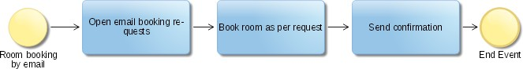

Fig. 53: Model Happy Path

Click here to return to the training task.

### Model Alternative Process Flows

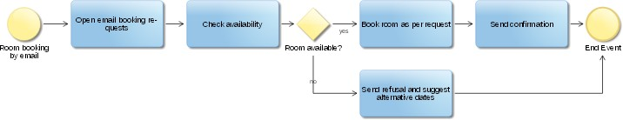

Fig. 54: Model Alternative Process Flows

Click here to return to the training task.

## Index

*A*

Access ADONIS NP via a REST API 129 Add existing object (tabular editor) 79 Add to favourites 92

Adjust column width (tabular editor) 78 ADONIS metamodel 3

Align objects 48

Analysis 81

Analysis without search term (search) 85 Analyst (Read & Explore) 35

Archive models (versioning) 71 Assign responsibilities to tasks 49 Automatically translate content 125 Autosave 131

Available filters (Search) 84

|  |  |  |
| --- | --- | --- |
| Available reports | 117 | |
| *B* |  | |
| BIA View 111  BPMN 2.0 4  BPMN DI Export | 127 | |
| BPMN DI Import BPMS 4  Bridges 131 | 127 | |
| *C* | |  |
| Change history 60  Change mode 51  Change password  131 Change property filter 52 Change user preferences 131  Check version history (versioning) | | 71 |
| Clear search results 87 Close model 44  Close Notebook 62  Cluster Map  112  Collaboration  92  Combine filters (search) 86 Compare models 99  Compliance (Read & Explore) 39 Connect objects 43  Connector functions Control & Release 27, 28  Copy & paste objects in catalogue | | 65 |

Create comment 93

Create folder in catalogue 64 Create group 64

Create model 40

Create model comment with open questions 93 Create new draft version (versioning) 71 Create object (tabular editor) 79

Create object in catalogue 65 Create objects 41

Create report  116

Create Task 26

Cross-hair 131

*D*

Dashboards (Read & Explore) 35 Delete image 62

Delete model in catalogue 67 Delete object (tabular editor) 79 Delete object in catalogue 67 Delete stored search query 88 Design & Document 25, 25

Display Full Text of Notification (Validation) 96 Display hits in documents 81

Display model (Validation) 96 Display object (Validation) 96 Display References 89

Dock Notebook 57

Document management 60 Documents (Read & Explore) 33 Drawing area 42

Drawing border 54

*E*

Edit attributes 57

Edit attribute values (tabular editor) 77 Edit mode (Notebook) 58

Edit translation content 123

Embed ADONIS NP as an iFrame 128 Embed models 128

Execute search 81

Execute stored search query 88 Exit validation 97

Explorer 63

Export analysis results 88 Export search results 88

Export table content (tabular editor) 80

*F*

Favourites (Design & Document) 27

Fill mandatory attributes (Validation) 97 Filter comments 94

Filter results (Validation) 96 Filter search results by Topic 82 Filter translated 125

Filter view by object type (tabular editor) 80 Fix Error Automatically (Validation) 97 Follow reference (textual view) 75

Format text 59 Fullscreen mode

Enter 55

Leave 55

*G*

Gantt View 111

Generate image 120

Generate URL 128

Get write access (translation editor) 124 Graphical modelling 40

Graphic Options 121

*H*

Heat map 109

Help 132

Hints 136

*I*

iFrame 128

Import file 60

Import Objects from Excel 126 Info 132

Info text 58

Initiatives (Read & Explore) 37 Interfaces 126

IT (Read & Explore) 34

*M*

Make Image Available in Different Language Versions 62 Manage references 58

Manage relations 58

Manage stored search queries 88

Mark ToDo as completed (Validation) 97 Matrix View 107

Mode 51

Model Catalogue 40

Model comparison 99

Export results 102

Navigate through results 101

Refresh results 101

Results 99

Start comparison 99 Switch active model 101 Switch base model 101

Model header Modelling bar 42

Modelling objects vs.repository Objects 45 Model navigation 50

Model Organiser 68, 68

Model Types 5

Mode view 131

Move model in catalogue 66 Move object in catalogue 66 Move objects 45

My BPM (Read & Explore) 33 My Roles 31

*N*

Navigate through results (validation) 95 Navigation bar

Collapse 54, 55

Expand 54, 55

Navigation shortcuts (translation editor) 124 Navigator 52

News and Tasks (all scenarios) 26 Notebook 55

Notebook chapter 58

Number Objects 48

*O*

Object Catalogue 40

Object Organiser 68

Open model 44

Open model in tabular editor 76 Open model in textual view 73 Open Notebook 56

Open Notebook of an object (tabular editor) 80 Open Notebook of an object (textual view) 74 Open Object Organiser 68

Open objects in tabular editor 76 Ownership (Design & Document) 26

*P*

Portal (Read & Explore) 32 Portfolio View 110

Post reply to comment 93 Print model 118

Print options 118

Processes (Read & Explore) 33 Process Owner (Read & Explore) 36 Property filter 51

Publishing 116

*R*

RACI (Read & Explore) 33 RACI matrix 109

Read & Explore 30, 31 Read mode (Notebook) 58 Refine criteria 83

Reject models (versioning) 71 Release models (versioning) 70 Release workflow 69

Remove from favourites 92 Remove model (Validation) 97 Remove object (Validation) 97 Rename model 67

Rename object  67

Replace object  66

Reporting Board 114

Choose category 114

Create reports 114

Open 114

Reporting Overview 117

Report options 116

Repository objects vs. modelling objects 45 REST API 129

Reuse object 45

Risks (Read & Explore) 34, 38

Run checks  95

*S*

Save model 44

Save search query 87 Scrolling 52

Search 81

Search in Comments 94 Search in documents only 85

Select attributes (tabular editor) 79 Select attributes (textual view) 74 Select cells (Tabular Editor) 78

Select display detail in the Drawing area 52 Select languages for translation 124

Select rows (Tabular Editor) 78 Settings 131

Share models 128 Share URL by email 128

Show/hide "Collaboration" widget 92

Show/hide details (textual view) 74 Show/hide Explorer 40

Show in graphical view 75 Show new Comments 94 Snap grid 54

Sort cells (tabular Editor) 78 Sort cells (textual view) 74 Start page 23

Submit to business review (versioning) 70 Submit to methodical review (versioning) 70 Subscribe to comments 92

Switch language 131

Synchronise objects 126

*T*

Tabular editor 76

Textual View 73

Textual viewer 73

Toggle editor 50

Transfer attribute values (tabular editor) 77 Translate content 123

Translate model 122

Translate object  122

Translation 122

Translation editor 122

*U*

Undock Notebook 57 Unsubscribe from comments 92 Upload image 62

Upload images and display them in the graphical editor 61 Usage Analysis 89

Usage in models 91 Usage overview 91

*V*

Validation 95

Versioning 69

View image 62

*Z*

Zoom 53



